**EzUITool Interface editing tool**

**User's manual**

***V80 – 2018.08***



Hotdisplay Technology Co.Ltd Technical Information

**Copyright notice**

Hotdisplay Technology Co.Ltd reserves the right to modify this document without prior notice. The information provided by Hotdisplay Technology Co.Ltd is believed to be accurate and reliable, but it does not guarantee that there are no errors in this document. Please ensure that the relevant technical documents and product specifications you use are up-to-date before placing an order with Hotdisplay Technology Co.Ltd.If your company uses our documents or products involving third-party patents or copyrights and other intellectual property rights, you are responsible for obtaining consent and authorization. This consent and authorization are not within the scope of our responsibility to ensure.

Update note:

2017-6 V52

* Add the long key message setting of the area button control and bitmap button control;
* Add the configuration content of the control message, and add the internal operation setting of the time and date display control;
* Modify the configuration content of the time and date display control;

2017-7 V60

* Adjust the configuration dialog box of control messages to set parameters for target controls that are string controls;
* Add partial control configuration data to associate control Settings (for EzUIH);
* Check all control ID numbers in the resource when modifying the control ID number to avoid duplication of ID numbers;

2018-2 V70

* Increase the configuration of the slider control (SliderCtrl);
* Select the bitmap redrawing property of the progress bar control;
* Add progress bar control configuration options to allow the configuration of a value control or string control;
* Modify the operation of temporary files, allowing multiple tools and resource files to be opened at the same time;
* Update the current selection after copying and pasting the control;
* Other detailed operational revisions;

2018-5 V72

* Add the configuration of the QR code display control;

2018-8 V80

* Add the function of undo and redo interface editing;
* Add the interface and some controls to trigger the GUI server engine message data packet sending enable switch setting;

**catalogue**

[Copyright notice 2](#_Toc32764)

[1 Tool introduction 6](#_Toc15096)

[1.1 EzUITool Tool introduction 6](#_Toc3807)

[1.2 EzUITool and EzUI series modules 6](#_Toc10439)

[1.3 EzUITool Tools involve file introduction 7](#_Toc28068)

[1.4 Requirements for related fonts 8](#_Toc11518)

[1.5 The number of resource items that can be loaded in a resource file 8](#_Toc13331)

[2 EzUITool Software interface 9](#_Toc17050)

[2.1 Tool bar 10](#_Toc4640)

[2.1.1 Resource file manipulation tool 11](#_Toc16109)

[2.1.2 The resource item loads the operation tool 11](#_Toc91)

[2.1.3 Controls and display command operation tools 12](#_Toc22205)

[2.1.4 Other general operating tools 14](#_Toc27910)

[2.2 Resource data operation display area 15](#_Toc24978)

[2.2.1 Engineering information 15](#_Toc4772)

[2.2.2 Interface controls 18](#_Toc29819)

[2.2.3 Interface instructions 20](#_Toc19521)

[2.2.4 Resource list 21](#_Toc30655)

[3 Create resource files for the module 23](#_Toc7366)

[4 Load resource items 24](#_Toc14171)

[4.1 Load ASCII font library 24](#_Toc2577)

[4.2 Load other resources 25](#_Toc11329)

[4.3 Operation of the Resource List TAB 26](#_Toc12715)

[4.4 Extract the color of the pixel 27](#_Toc27821)

[5 Interface creation 29](#_Toc27731)

[5.1 Create a new interface 29](#_Toc25617)

[5.2 Operations on the tree table interface in the project information 30](#_Toc16052)

[6 Add interface display instructions to the interface 31](#_Toc14179)

[6.1 Set backlight and clear screen 31](#_Toc2307)

[6.2 Draw a straight line 33](#_Toc8399)

[6.3 Interface instructions list operations 34](#_Toc13400)

[6.4 image display 37](#_Toc9762)

[6.5 String is displayed 38](#_Toc21503)

[6.6 General control resource Settings 40](#_Toc26475)

[6.7 Save the resource file 42](#_Toc8719)

[6.8 Edit other interfaces 42](#_Toc28569)

[7 Interface control Settings 44](#_Toc14861)

[7.1 Setting of the regional button control 44](#_Toc32550)

[7.2 Configure control messages 48](#_Toc18798)

[7.3 Settings for other controls 53](#_Toc18706)

[7.3.1 Bitmap button control Settings 53](#_Toc27936)

[7.3.2 Value control Settings 56](#_Toc7353)

[7.3.3 String control Settings 57](#_Toc27795)

[7.3.4 Set the drop-down selection control 58](#_Toc2886)

[7.3.5 Progress bar control Settings 59](#_Toc17879)

[7.3.6 Waveform control Settings 61](#_Toc19923)

[7.3.7 Bitmap animation control Settings 63](#_Toc23491)

[7.3.8 A time display control 65](#_Toc6518)

[7.3.9 Display the date control 66](#_Toc24135)

[7.3.10 The dial displays controls 66](#_Toc1618)

[7.3.11 Slider control 69](#_Toc16055)

[7.3.12 QR code display control 72](#_Toc18938)

[7.4 Modify the set controls and control messages 74](#_Toc1161)

[7.5 Operations in the tree table of the interface control 75](#_Toc4803)

[8 Interface switching Settings 77](#_Toc30094)

[8.1 Enable configuration interface switching effect and interface switching message sending 77](#_Toc3895)

[8.2 Set touch swipe to switch 78](#_Toc31953)

[9 Technical Support 80](#_Toc16945)

[9.1 contact way 81](#_Toc19900)

# Tool introduction

## EzUITool Tool introduction

EzUITool is a tool software designed for EzUI series (including EzUILet series) modules to integrate resources, edit interface and configure controls. Users can use this tool to complete the basic display interface design, as well as configure the display content of each display interface, control configuration, and message response mechanism between controls.

## EzUITool and EzUI series modules

EzUITool The tool can generate a resource file, which contains preset display resources and interface data. The preset display resources mainly consist of pictures, font libraries, common control resources, etc., which are required by the user interface; these preset display resources are all basic materials of the entire user interface.

The interface data is the multiple display interfaces that users edit for resource files on the EzUITool tool. Each interface has a unique interface index number; users can preset multiple ordinary display operation instructions for each interface, set multiple controls and configure the response messages between the controls.

EzUITool The suffix of the resource file generated by the tool is ".ers". This resource file needs to be preset in the resource memory of the EzUI series module. When the EzUI series module works, it reads and analyzes the resource file from the resource memory on the module, and displays and responds according to the interface edited in the resource file.

EzUITool The process of resource production is shown as follows:

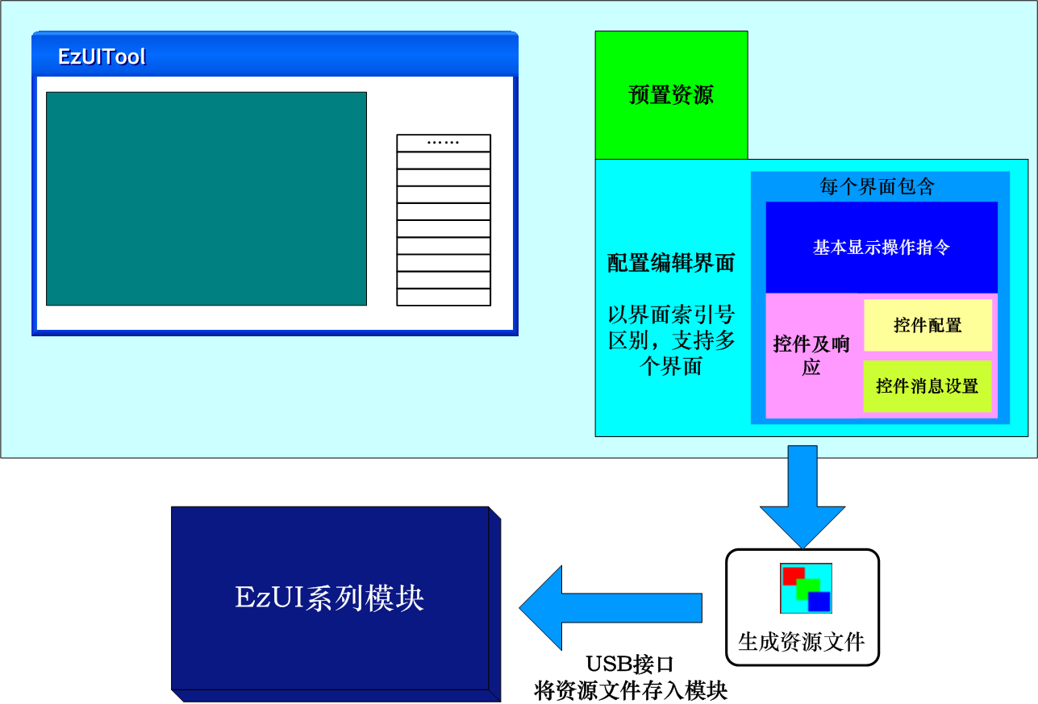

## EzUITool Tools involve file introduction

EzUITool Some documents will be involved, which will be explained here.

* ".ers": EzUITool Resource file created.
* ".tmp": EzUITool Temporary files generated during use.
* ".bmp": EzUITool bitmap files that can be loaded, but require the bitmap file to be in Windows format and support 24-bit color, 8-bit color, 4-bit color, and monochrome bitmap files.
* ".jpg": EzUITool can load JPEG image files. The actual module only supports EzUIH series of resources and display.
* ".hzk": EzUITool can load the Chinese character library file, which requires that the file name starts with "single character width X single character height", that is, the 24x24 point Chinese character library file name must be: "24X24.hzk"; in addition, the Chinese character library must be a GB2321 standard first and second level Chinese character library.
* ".asc": An ASCII English font file that can be loaded by EzUITool. The file name must start with "single character width X single character height", that is, the 16x32 dot English font file name must be: "16X32.asc".
* ".big": The EzUITool version can load the Big5 Traditional Chinese font library. The file name is required to be the same as ".hzk", but the Big5 font library is only supported by some modules for display.
* ".nir": A numerical input box resource file generated by the NIS\_ResourceEditTool tool. It belongs to the category of common controls in the EzUI series module. The EzUITool can load this type of file as a basic resource item in the resource file.
* ".sir": A string input box resource file generated by the SIS\_ResourceEditTool tool. It belongs to the category of common controls in the EzUI series module. The EzUITool can load this type of file as a basic resource item in the resource file.

## Requirements for related fonts

The data of the font library (which is a collection of glyphs) uses the same data composition method as a typical monochrome dot matrix LCD. That is, one bit in the glyph represents one pixel on the LCD display, with the scanning order being from left to right and top to bottom. For this reason, the requirements for the glyphs in the ASCII English font library are the same as those in the Chinese font library.

The font uses a bit stream structure in bytes, that is, when the number of points in a line is not an integer multiple of 8, the data is filled to 8 bits and the unused bits are filled with zero.

The font file should be named according to the requirements in the previous section, otherwise it cannot be loaded properly.

The ASCII English font has 256 characters.

## The number of resource items that can be loaded in a resource file

EzUITool Tools The maximum number of resource items (i.e., sub-item resources) supported by a resource file is 400.

A resource file allows up to 150 interfaces to be created.

# EzUITool Software interface

Double-click "EzUIToolV80.exe" to open the new resource file configuration dialog box, as shown in the following interface:

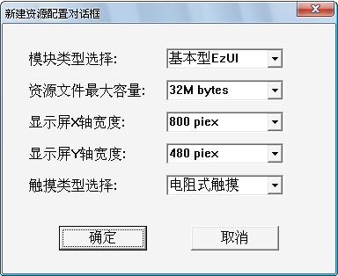

EzUITool Tools are document-based software structures, so before opening the main body of the software, you need to associate the software with a newly created or existing resource file; here, users can configure an option for a new resource file, which includes the maximum capacity of the resource file, the number of X and Y axes on the display, touch enablement options, and large resource mode options.

Module type selection: The corresponding module types of the newly created resource files need to be selected, including basic EzUI series modules, streamlined EzUILet series modules, and increased EzUIH series modules; the actual module configuration will be used when the module executes the resource file.

Touch type selection: The touch configuration of the module used should be selected, which is no touch, resistive touch and capacitive touch (only EzUIH series supports).

After pressing the "OK" button in the new resource file dialog box, you can enter the main interface of the software, as shown in the following figure:

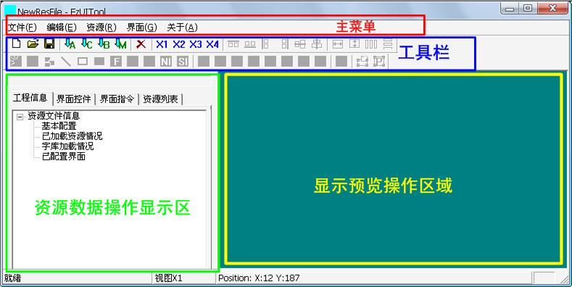

EzUITool The main interface of the tool mainly contains four parts, which are:

* primary menu;
* tool bar;
* Display the preview operation area;
* Resource data operation display area.

## Tool bar

EzUITool Tool software is an integrated tool that combines resource integration and interface editing. Users can load bitmaps, font libraries, and other resources for the EzUI series modules within the software. They can also edit module interfaces and set controls and configure control messages. To achieve these functions, the shortcut tools on the EzUIToolr toolbar basically cover all possible resource loading and interface editing operations, including several major categories of tool buttons:

* Resource file manipulation tools: 
* Resource item loading operation tool:
* Controls and display command operation tools:

(Note: The toolbar in this area is an interface control or display instruction alignment adjustment tool. When the current selected page does not meet the requirements, it will be displayed as a gray impossible state)



* Edit operation undo, redo tools:
* Other general operating tools:

In different functional interfaces, the toolbar and resource data display area of EzUITool tools will provide different displays and functions.

### Resource file manipulation tool

: The first item in the toolbar is the tool button for creating a new resource file. If the user clicks this button, it will open the dialog box for creating a new resource file. In this dialog box, you can open the "New Resource Configuration Dialog Box" that pops up when EzUITool tool software is opened, and complete the operation of creating a new resource file.

: The second item in the toolbar is the open resource file tool button. Users can click this button to open a saved resource file (suffix: ".ers").

****: The third item in the toolbar is the resource file save tool button. Users can click this button to complete the operation of saving the resource file;If the resource file to be saved is a newly created resource file, a file save dialog box will pop up, and users can set the path and name of the file to be saved in this dialog box.

### The resource item loads the operation tool

: The font library resource loading tool button, the user can press this button to open a font library file loading dialog box, in which the operation of loading the font library to the resource file can be completed; it can complete the loading of ASCII font library.

: The Chinese font library resource loading tool button, the user can press this button to open a Chinese font library loading dialog box, in which the operation of loading the Chinese font library to the resource file can be completed.

: Bitmap resource loading tool button, the user can press this button to open a bitmap loading dialog box, in which the bitmap file loading to the resource file operation can be completed.

: The button for loading the common control resources. Users can press this button to open a dialog box for loading the common control resources, and complete the operation of loading the "value input box resource" or "string input box resource" file to the resource file.

: The button of Jpeg image resource loading tool allows users to press this button to open a Jpeg image file loading dialog box, and complete the operation of loading Jpeg image file to resource file. **(Note: Only EzUIH series modules support Jpeg image resource items)**

### Controls and display command operation tools

: Backlight setting instruction tool button, the user can click this button to add a backlight setting instruction to the current interface, which is equivalent to setting the backlight brightness.

: Clear screen instruction tool button, the user can click this button, will use the drawing color set before the instruction to perform a full screen clearing operation.

: Drawing color setting instruction tool button, the user can click this button to complete the drawing color setting and drawing line width setting in the open dialog box.

: The straight-line drawing state setting tool button. If the user presses this button, the button will be in the pressed state, indicating that the current user can use the mouse to draw a straight line in the display area; the straight-line drawing state will remain until another drawing operation button is pressed, that is, switching to another drawing operation state.

: The rectangular frame drawing status setting tool button. If the user presses this button, it will be in the pressed state, indicating that the current user can use the mouse to draw a rectangular frame in the display area; the rectangular frame drawing status will remain until another drawing operation button is pressed, which means switching to another drawing operation state.

: Solid rectangle drawing status setting tool button, if the user presses this button, the button will be in the pressed state, that is, the current user can use the mouse to draw solid rectangle in the display area.

: The font library setting instruction tool button, the user can click this button, in the open dialog box to complete the font library selection Settings, and character color Settings

: The string display status setting tool button. If the user presses this button, the button will be in the pressed state, indicating that the current user can use the mouse to display the string in the display area.

: Image display command tool button, click this button will open a bitmap selection dialog box, the user can set the position of the image to be displayed and the image resource to be displayed (the premise is that the resource file has been loaded, for EzUIH series modules can also be used to display the Jpeg image in the resource file).

: The button for resource allocation of numerical input box. Clicking this button will enable you to complete the selection and configuration of input box resources in the opened dialog box. EzUI series modules require users to configure the resource of numerical input box in the interface if they want to use the function of pop-up numerical input dialog box of numerical control.

: String input box resource allocation button. Click this button to complete the selection and configuration of input box resources in the open dialog box. EzUI series modules require users to configure the string input box resources in the interface if they want to use the function of pop-up string input dialog box of string control.

: The region button control status tool button, when pressed by the user, will be in a pressed state, indicating that the current user can use the mouse and the pop-up dialog box to complete the addition and setting of the region button control; the region button control status will remain until another control setting status button is pressed, which means switching to another control setting status.

: Bitmap button control set status tool button, if the user presses this button, the button will be in the pressed state.

: The numerical control set state tool button. If the user presses this button, the button will be in the pressed state.

: String control set status tool button, if the user presses this button, the button will be in the pressed state.

: The drop-down selection control sets the status of the tool button. If the user presses this button, the button will be in the pressed state.

: The progress bar control sets the status of the tool button. If the user presses this button, the button will be in the pressed state.

: Bitmap animation control set status tool button, if the user presses this button, the button will be in the pressed state.

: Waveform control set status tool button, if the user presses this button, the button will be in the pressed state.

: The time display control sets the status of the tool button. When the user presses this button, the button will be in the pressed state.

: The date display control sets the status of the tool button. When the user presses this button, the button will be in the pressed state.

: The dial display control button shows the status of the control setting. When the user presses this button, the button will be in the pressed state. **(Note: Only EzUIH series modules support)**

: The slider control sets the status of the tool button. After the user presses this button, the button will be in the pressed state. (Note: Only EzUIH series modules support)

: The QR code display control is a tool button to set the status of the button. When the user presses this button, the button will be in the pressed state. (Note: Only EzUIH series modules support this.)

: The button of the control message configuration tool. If the user presses this button, a control message can be configured for the selected control.

: The area modification tool allows users to set or display instructions for the control in the selected state in the resource data display area by pressing this button.

: Position modification tool, the user can press this button to set or display instructions for the control in the selected state in the resource data display area to perform precise area position modification operation.

: Multiple selection controls or display instructions are aligned at the top;

: Multiple selection controls or display instructions are aligned at the bottom;

: Multiple selection controls or display instructions are aligned to the left;

: Multiple selection controls or display instructions are aligned to the right;

: Select multiple controls or display instructions to align horizontally;

: Multiple selection controls or display instructions are aligned vertically to the center line;

: Multiple selection controls or display instructions to adjust the width;

: Multiple selection controls or display instructions and other high adjustment;

: Multiple selection controls or display instructions to adjust the horizontal spacing;

: Multiple selection controls or display instructions are adjusted vertically at equal intervals;

### Other general operating tools

: Delete button, the user can press this button to delete the selected interface items or interface control Settings, control messages, display instructions and resource items in the resource data operation display area (the deletion operation will depend on the current editing status of the user).

: View zoom Settings button, the user can press the corresponding button to set the display zoom factor of the "display preview" area.

## Resource data operation display area

The resource data operation display area consists of four operation navigation tabs, which are:

* Project information: display the overall information of the entire resource file project, users can create, delete and so on;
* Interface control: display the control Settings and control messages in the interface that is currently in the editing state. Users can select, delete, copy, paste and other operations of controls and control messages;
* Interface instruction: display the display instructions in the interface that is currently in the editing state. Users can select, delete, copy, paste and other operations of the display instructions;
* Resource list: Displays the resource items loaded in the current resource file.

### Engineering information

As shown in the figure below, the overall information of the entire resource file will be displayed on this TAB, and there is a progress bar at the top to show the size of the current resource file:

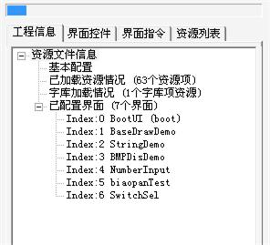

* Basic configuration: Double-click this item to open a dialog box that displays the basic information of the current resource file project, and you can configure the communication port (UART) baud rate for the EzUILet series module.

Double-click "Basic Settings" to open the dialog box, as shown in the following figure:

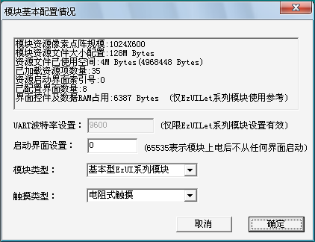

The following information and configuration options for several resource files are noteworthy:

**Interface Controls and Data RAM Usage:** This information is for reference only when using the EzUILet series modules. The GUI service engine of the EzUI series modules requires dynamic RAM to generate controls and interface data. The required RAM size depends on the number of interfaces and their complexity as specified in the resource file. When using the EzUILet series modules, ensure that this value is less than the number of bytes of dynamic RAM provided by the module (as detailed in the datasheet).

**UART baud rate setting:** This setting is only valid for the reduced EzUILet series modules; for the basic EzUI series and enhanced EzUIH series modules (i.e., modules that are recognized as USB drives when connected to a computer via the module's USB interface), the UART baud rate is defined by the configuration file in the module's USB drive. For some EzUILet modules that support the SPI interface, if you need to use the module's SPI interface, you must set this value to 0 in the resource file.

**Start interface setting:** This item can indicate that the module starts up and starts displaying from the interface with the specified index number; when this item value is 65535, it indicates that the setting is invalid.

**Module type:** Select the module type corresponding to the resource file, which is the basic EzUI series module, the streamlined EzUILet series module, and the added EzUIH series module; the module will be executed according to the actual configuration of the module.

**Touch type:** The touch configuration of the module used should be selected, which is no touch, resistive touch and capacitive touch (only EzUIH series supports).

* **Configured Interface:** This item can be expanded to display the configured interface details. Sub-items below provide information about each interface, including the "index," which is the **interface index number**, and the interface name. Double-clicking on a corresponding interface item allows you to enter the interface for editing; clicking once selects the corresponding interface item.

Users can use the right mouse button pop-up menu in the engineering information tab to perform relevant operations, such as right-click on the "configured interface" item to pop up a quick menu:

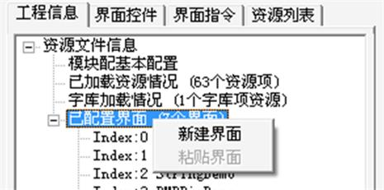

"New interface": Create a new interface.

"Paste interface": can paste the copied interface into a new interface; if there is no previous interface copy operation, this item is gray and unavailable.

When the user right-clicks on an interface item that has already been created and configured, a different menu will pop up, as shown in the figure below:

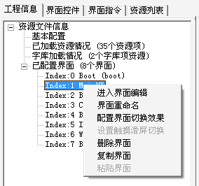

"Enter interface editing": Select this item to enter the selected interface editing state, and users can set the controls, control messages and display instructions required for editing on the interface.

"Rename the interface": Select this item to open a dialog box in which you can rename the selected interface.

**"Configuration interface switching effect"**: Select this item to open the dialog box, in which you can set the switching effect of the selected interface (only for EzUIH series modules), and set the enabling of interface switching message sending.

**"Set touch slide screen switch"**: This menu is only valid for EzUIH series modules equipped with capacitive touch screen. Select this item to open the dialog box, in which you can configure the target interface to be switched when sliding left and right on the selected interface.

"Delete interface": Select this item to delete the selected interface.

"Copy interface": Copies the selected interface.

"Paste interface": Paste the copied interface data to create a new identical interface.

### Interface controls

When the user double-clicks on the interface item in the "Engineering Information" tab or uses the menu that pops up with the right mouse button to enter the interface editing, the user can view the controls and control message configurations contained in the interface in the "Interface Controls" tab page, and can select, copy, and paste controls or control messages.

The following figure shows the display after entering the interface named "BootUI" and switching to the "Interface Controls" TAB:

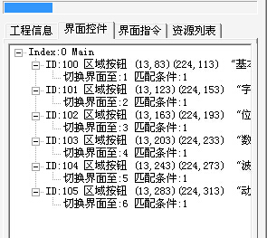

In the tree list of the tag page, the root item will display the index number and name of the current editing interface. For example, in the above figure, the index number of the edited interface is 0, and the name of the interface is "BootUI".

The lower-level items expanded from the root item are controls. Each control displays its control ID number, control type, and basic information; the control ID number is the unique identifier of the control, with standard control IDs starting from 100. In the resource file, all control ID numbers in all interfaces cannot be duplicated. In the above diagram, this interface has already configured control IDs as follows: 100,101,102,103,104,105; all belong to the area button control.

If the control is configured with control messages, you can expand the sub-items under the control entry to display the control messages associated with that control. In the figure above, corresponding control messages have been added for each control (**control message:** refers to when a touch event or other configured events occur on the control, the EzUI module will automatically perform actions according to the configured messages, such as switching interfaces, adding or subtracting values from other controls).

**Select a control or control message:**

The user can click the left mouse button to select corresponding controls or control messages. Additionally, the user can click the corresponding controls or control messages while pressing the "Ctrl key" on the keyboard to make multiple selections. The user can also select multiple controls and control messages by selecting them in the tree view of the "Interface Controls" tab.

If you click the left mouse button in the blank area of the tree table, you can cancel the selected control or control message.

**Double-click the control or control message:**

Double-click the corresponding control or control message with the mouse, and the configuration dialog box of the control or control message will be opened. Users can configure the properties of the control or control message in the dialog box.

**Right-click menu:**

Right-click on the "Interface Controls" TAB to bring up a shortcut menu, as shown in the following figure:

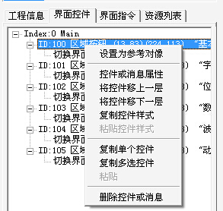

"Set as reference object": The control pointed to by the pop-up menu can be set as a **reference object** (multiple selection controls or reference objects when display instructions adjust to equal width or height).

"Control or message properties": Select this option to open the corresponding control or control message property Settings dialog box.

"Move the control up one level": Select this option to move the corresponding control (control messages are not available) up one level (Note: The interface is redrawn in the order of the control in the tree table).

"Move the control down one level": Select this option to move the corresponding control (control messages are not available) down one level.

"Copy control style": Select this option to copy the properties of the corresponding control (control messages are not available).

"Paste control style": Select this option to copy the previously copied control properties to the corresponding control, but only for the same type of control.

"Copy a single control": Select this option to copy the control pointed to by the cursor in the pop-up menu.

"Copy multiple controls": Select this option to copy multiple controls currently selected. If the multiple items contain control messages, only the controls in the selected state are copied.

"Paste": Paste one or more controls copied into a new control and assign them an idle ID number.

"Delete Controls or Messages": Select this option to delete controls or control messages that are in the selected state.

### Interface instructions

When the user double-clicks the interface item in the "Engineering Information" TAB or uses the menu popped up by right-click to enter the interface, the user can view the display instruction configuration contained in the interface in the "Interface Instruction" TAB page, and can select, copy, paste and other operations on the display instruction.

The following figure shows the display after entering the interface named "BootUI" and switching to the "Interface Directive" TAB:

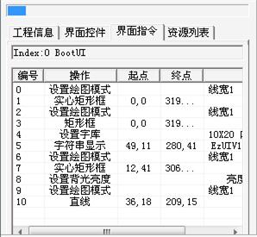

The list in the "Interface Commands" tab shows the display commands configured for the interface, such as setting drawing modes, drawing lines, drawing rectangles, setting font libraries, string display, and backlight settings. Each item has an index number of the display command within that interface. When the EzUI module displays this interface, it will sequentially execute the display operations starting from index number 0.

**Select the interface to display instructions:**

Users can click the left mouse button to select the corresponding display instruction items. In addition, users can also click the corresponding display instruction items to select multiple items by pressing the "Ctrl key" on the keyboard; users can also select multiple display instructions by selecting the list on the "Interface instruction" tab page.

If you click the left button in the blank space of the list, you can cancel the selected display instruction.

**Double-click the interface to display instructions:**

Double-click the corresponding display command item with the mouse to open the configuration dialog box of the display command, and users can set the display command in the dialog box.

**Right-click menu:**

Right-click on the "Interface Directive" TAB to bring up a shortcut menu, as shown in the following figure:

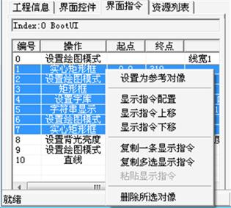

"Set as reference object": The display instruction pointed to by the cursor in the pop-up menu can be set as a **reference object** (the reference object is used when the multiple control or display instruction adjusts to equal width or height).

"Display instruction configuration": Select this option to open the corresponding display instruction property Settings dialog box.

"Move the display command up": Select this option to move the corresponding display command up one position (Note: The interface will be redrawn in accordance with the order of the display command list).

"Move the display command down": Select this option to move the corresponding display command down one position.

"Copy a display command": Select this option to copy the corresponding display command.

"Copy multiple display instructions": Select this option to copy the selected multiple display instructions.

"Paste display instructions": Paste one or more copied display instructions into new instructions and place them at the end of the list.

"Delete selected object": Select this option to delete the display instructions that are in the selected state.

### Resource list

Users can switch the navigation TAB to this page at any time, where they can view the loaded resource items in the current resource file.

The following figure shows the list of resource items in a resource file:

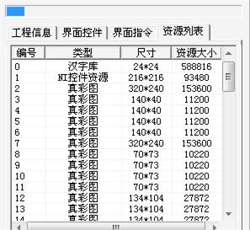

Each item in the resource list is assigned a unique number, which indicates the storage sequence of the corresponding resource item in the resource file. When users use the loaded resources in the configuration of interface controls and display instructions, they need to specify the corresponding resource item with this number.

**Click the left mouse button to select:** In the resource list, clicking with the left mouse button will select the corresponding “”resource item. After selection, you can click the "Delete Tool" button in the toolbar to remove the corresponding resource item from the resource file; Additionally, if a resource item is selected in the list, newly loaded resource items will be inserted before it. If no item is currently selected, the newly added resource item will be loaded at the end of the list. Clicking on an empty entry in the resource list will cancel the current selection of the resource item.

**Double-click the left button to display:** In the resource list, users can use the left mouse button to double-click a certain resource item, and then they can view the resource in the preview operation area; it should be noted that if you double-click a certain resource item, you will exit the current editing interface.

# Create resource files for the module

After the user opens the EzUITool tool software, a basic configuration dialog box will pop up. Select the pixel configuration of the resource file here, as shown in the following figure:

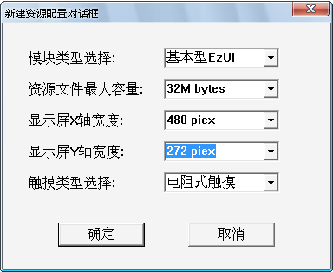

**Module type selection:** EzUI043 The module is the basic EzUI series module, and the corresponding Settings are selected.

**Maximum capacity of resource file:** When selecting this setting, users should choose the specific module to be used. The EzUI series and EzUIH series modules have large memory, so you can choose a larger resource file, while the EzUILet series modules have small memory, please select according to the specific situation.

**Display X/Y Axis Width:** This configuration should be determined by the user based on the module to be used. For EzUI series modules, users are typically not allowed to switch between landscape and portrait modes, so this setting must be fixed and adapted to specific modules. However, for EzUILet and EzUIH modules that allow resource files to determine the module's landscape or portrait mode, you can choose the appropriate pixel array for display. For example, if the standard display mode for a EzUILet024 module is portrait, then set "Display X Axis Width" = 240 pixels and "Display Y Axis Width" = 320 pixels. If you want to display the EzUILet024 module in landscape mode, set "Display X Axis Width" = 320 pixels and "Display Y Axis Width" = 240 pixels.

**Touch type selection:** depends on the specific module.

In this document, the EzUI043 module will be used as an example. Therefore, the maximum resource storage capacity is selected to be 32M (it can be larger), the X-axis width is 480, and the Y-axis width is 272; the touch type is selected as resistive touch. After selecting, press "OK" to complete the creation of a new resource file.

# Load resource items

After creating a new resource file, the resource items of the resource file are empty. Switch the navigation tab to "Resource List" to observe the loading of resources.

The following figure shows a schematic diagram of a resource file created in the previous chapter (480X272 points, 32M capacity):

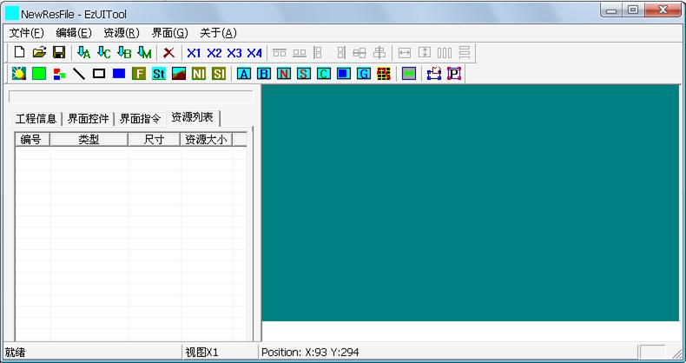

The following examples will introduce how to use the resource loading interface, as well as the display instructions and operations of each block in this interface.

## Load ASCII font library

Click the "" button in the toolbar to open an ASCII font library loading dialog box, as shown in the following figure:

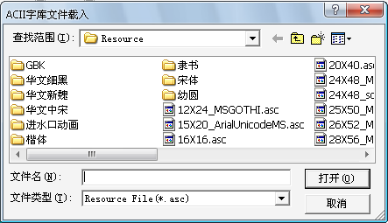

In the opened dialog box, select an ASCII font resource file to load. Here, you will load a 24x48 dot matrix ASCII font file. After selecting it, click the "Open" button in the dialog box. The tool software will pop up a prompt dialog box to inform the user of the properties of the loaded ASCII font file, as shown in the figure below.

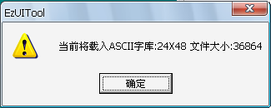

The user simply clicks the "OK" button, and then the "Resource List" will display the resource items loaded into the resource file, as shown in the following figure:

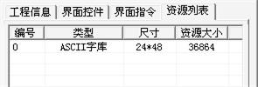

The resource item list presents the resources loaded from the resource file in a list. When the user operates on the resource items (such as setting the font library, displaying the bitmap, etc.), he or she needs to know the **number** of these resource items in the resource file, that is, the resource index number.

## Load other resources

The loading method for Chinese font resources, bitmap resources, and common control resources is similar to that of ASCII fonts. Users only need to press the corresponding buttons in the toolbar, such as,,, assume you are loading a 16x16 Chinese character library, a numeric input box resource (suffix ".nir"), a character input box resource (suffix ".sir"), and a bitmap file.

When loading bitmap file resources, there are some special places. EzUITool will preprocess the bitmap file. If the size of the bitmap resource can be changed by using image compression, it will prompt the user whether to use the compressed method to load the bitmap file; for example, to load a bitmap file as shown in the following figure:

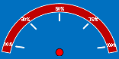

In the figure above, most of the area of the image uses the same color. EzUITool will automatically determine the compression of the file and prompt the user whether to use the compression mode when loading, as shown in the figure below:

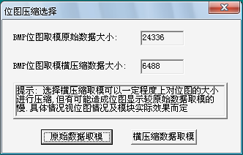

As shown in the figure, if the bitmap to be loaded is modulo using the original data, it will occupy 24336 bytes of space, while if the horizontal compressed data is modulo using the original data, it will occupy 6488 bytes of space; in general, users are advised to use "original data modulo".

After the assumed resource items have been loaded, the Resource List TAB will display as follows:

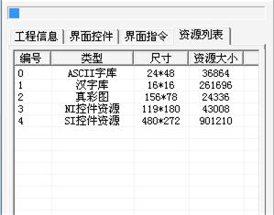

## Operation of the Resource List TAB

In the resource list, you can perform some operations to facilitate the loading, deletion, and viewing of resources.

In the resource list, users can select a specific resource item by clicking with the left mouse button. Before loading resources, if a resource is in the selected state in the resource display area, subsequent loading operations will add the newly loaded resource item before the previously selected one. The remaining resource items (including those that were previously selected) will then be pushed back sequentially.

When the user clicks on an invalid list item (that is, there is no valid resource item at that location) in the resource item list, the selection of the resource item can be cancelled.

If a resource item is in the selected state, you can delete the selected “”resource item by clicking the delete Tool button in the toolbar.

And users can view a specific resource item by double-clicking it with the left mouse button. At this point, the content of that resource item will be sampled and displayed in the display area of the resource loading interface. For example, if you click on the 0th resource (ASCII font library) just loaded, the display in the area will look as follows:

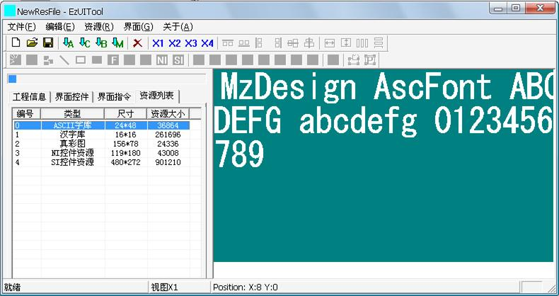

If you double-click the second resource item (Bitmap resource), it will be displayed as shown in the following figure:

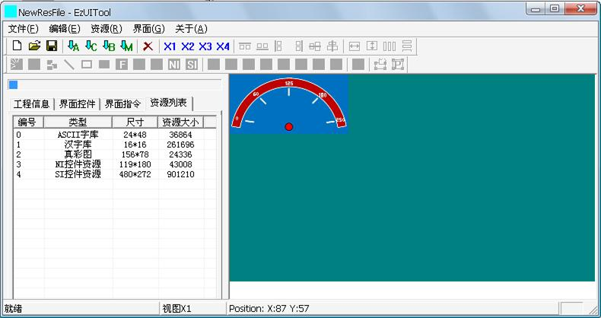

## Extract the color of the pixel

When double-clicking a resource item, the character or image of the resource item is displayed in the preview operation area. If the user wants to obtain the color information of a point, he/she can use the right mouse button pop-up menu in the preview operation area to obtain the color information of the point, as shown in the following figure:

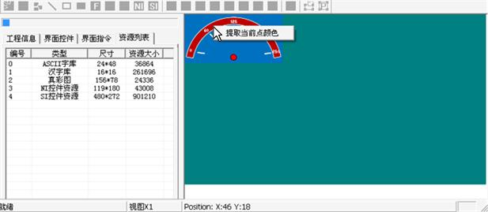

Click the "Extract current point color" item in the pop-up menu, and a dialog box will pop up, as shown in the following figure:

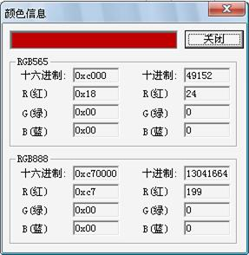

# Interface creation

The default number of interfaces for the newly created resource file is 0. Users need to create the required interfaces for the resource file in order to add necessary controls and display instructions in the interface; whereas the EzUI series module will execute the resource file by default from the interface with index number 0.

Take the resource file that loaded the resource item in the previous chapter as an example, switch to "Project Information" in the navigation TAB bar, as shown in the following figure:

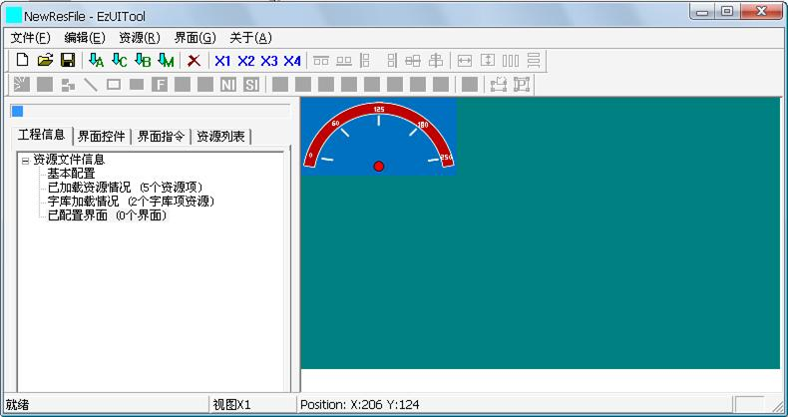

At this time, the "Engineering Information" tab of EzUITool shows that there is no interface item in the current resource file.

## Create a new interface

Right-click on the "configured interface" in the tree table, and then select "New Interface" in the pop-up menu to open a new interface dialog box, as shown in the following figure:

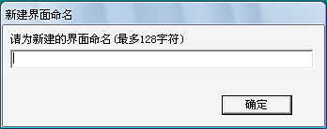

The user can name the new interface in the dialog box. For example, if you enter "Boot UI", after pressing the "OK" button, all the interface information of the current resource file will be displayed in the resource data display area, as shown in the following figure:

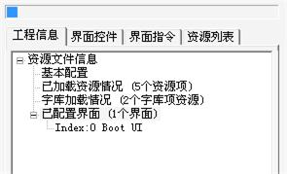

As can be seen in the figure above, a new "Index: 0 Boot UI" is added to the tree table; "Index: 0": that is, the index number of the interface. When users use the EzUI series module, the module will start to display from the interface with index number 0 by default after power on;

## Operations on the tree table interface in the project information

According to the previous method, create two more interfaces, "Work UI1" and "Work UI2". At this time, the display in the resource data display area is as follows:

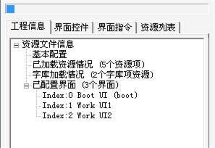

This is equivalent to the current resource file, there are 3 empty interfaces.

Users can operate these interfaces in the tree table. When users click on an item in the list with the left mouse button, the interface can be in the selected state; when one interface is in the selected state,  the delete button in the toolbar can be pressed to delete the interface.

Right-click the mouse and click on an item in the tree table. A menu will pop up, and you can select relevant menu items to perform relevant operations, such as copy, paste, rename the interface, delete, etc.

By double-clicking an interface item with the left mouse button, you can display the display effect of the interface in the preview area and enter the editing of the interface.

# Add interface display instructions to the interface

Take the resource file of the resource item loaded in the previous chapter as an example. Double-click "Boot UI" with the left mouse button, that is, the interface item with index number 0, and enter the editing of the interface. Then switch to "Interface Directive" in the navigation TAB bar, as shown in the following figure:

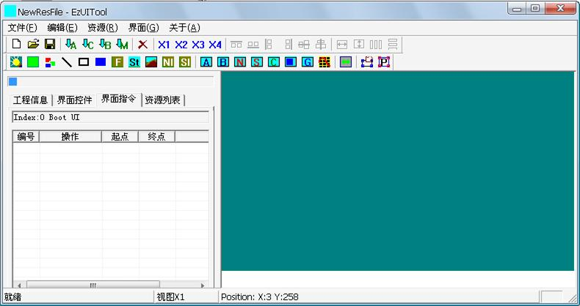

Since the interface was previously in an empty state, the list of instructions for the interface is empty.

## Set backlight and clear screen

In the interface of the previously created resource file with an index number of 0, users can use the toolbar's operation command buttons to perform basic display operations, such as drawing lines and rectangles; however, the EzUI series modules are based on TFT displays. When the backlight brightness is low or the backlight does not light up, the screen display cannot be seen. Therefore, in the interface, it is usually necessary to first set the backlight and perform some essential basic display operations, such as clearing the screen.

Click the tool button “”in the toolbar to open a backlight Settings dialog box, as shown below:

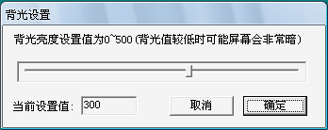

In the dialog box, you can drag the progress bar to set the brightness of the backlight. Click "OK" to complete the addition of a backlight setting instruction for the interface. After adding, the list in the "Interface Instruction" tab will show the current display operation instruction added, as shown in the following figure:

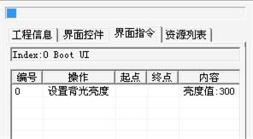

After setting the backlight, you can operate to clear the screen display, but first you need to determine the color of the screen, so click the drawing color settings tool button in the toolbar, which will open a dialog box, in which you can complete the drawing color setting and drawing line width setting, as shown in the following figure:

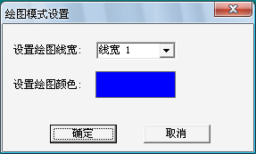

In the dialog box, you can select the drawing line width to be set in the drop-down menu under "Set Drawing Line Width." However, the drawing line width only affects straight lines and rectangular boxes; thus, you can ignore modifying its settings. Users can click on the area to the right of "Set Drawing Color" to open a color selection dialog box, where they can complete the color selection. Here, choose blue as the drawing color. After setting it, click the "OK" button, and the instructions in the list of the "Interface Commands" tab will appear as shown in the following figure:

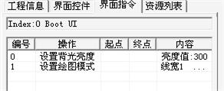

At this point, click  the "Clear screen tool" button in the toolbar to clear the display area with the drawing color previously set, and add the clear screen instruction (actually implemented by the instruction of drawing solid rectangle) in the resource data display area, as shown in the following figure:

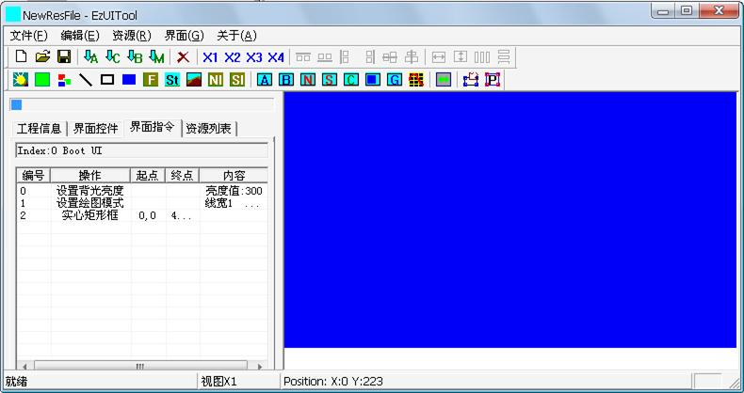

## Draw a straight line

Before drawing a straight line or creating a rectangular frame, solid rectangle, and other drawing operations, you need to determine the drawing color and line width. Previously, you have set the drawing color once, but that setting was for clearing the screen. If you wish to draw a straight line or perform other drawing operations in a different color, you need to set the drawing color again before starting the drawing operation.

Next, draw a red line with a width of 3 pixels; first click the "Drawing color Settings" button in the toolbar, and set the following in the opened drawing color Settings dialog box:

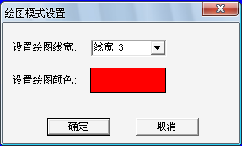

Click OK, and the current instruction in the list of the "Interface Directive" TAB is shown in the following figure:

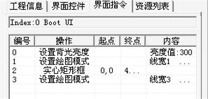

After setting the new drawing color and line width, click the "Straight line drawing state setting tool button" in the toolbar to make the tool currently in the straight line drawing state. At this time, "" will be in the pressed state.

Then, to draw the starting point of a straight line in the display area, press the left mouse button. When dragging the mouse, a straight line will be drawn immediately, as shown in the figure below:

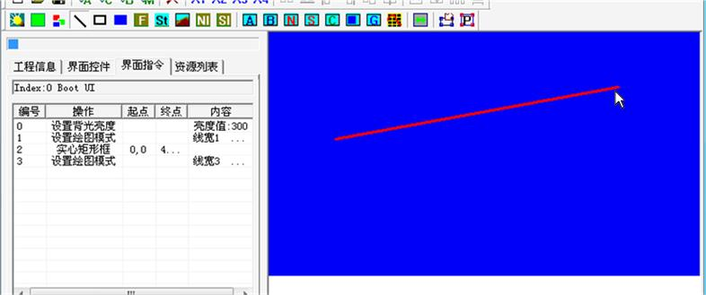

To draw a straight line, release the mouse at the end of the line. At this time, the drawing instruction will be added to the list in the "Interface Instruction" TAB, as shown in the following figure:

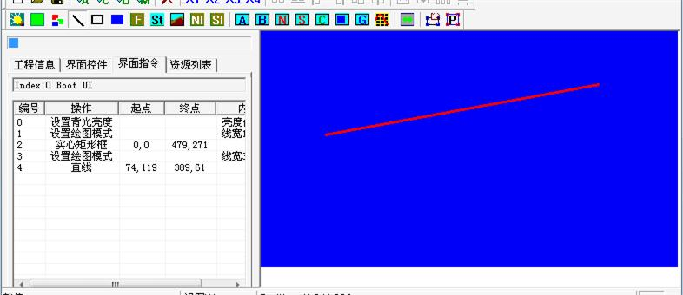

## Interface instructions list operations

After adding several ordinary display operation instructions, you can see multiple instructions in the list of the "Interface Instructions" TAB. Users can select one instruction in the list to perform some operations, such as modifying the instruction, deleting the instruction, etc., but there is a principle that users need to understand:

* The EzUI series modules, when loading and displaying a certain interface, will execute in the order listed in the standard display operation instructions, with the smallest numbered instruction executed first; for example, each setting of the drawing color determines the subsequent drawing color and line width until the next setting of the drawing color; similarly, font library settings and other commands follow this principle;

When a display instruction is in the selected state, you can press the "" delete button in the toolbar to delete the selected display instruction. Alternatively, you can also delete it by selecting "Delete the selected object" from the right-click menu.

For entity objects (interface controls and display instructions such as straight lines, rectangles, bitmap displays, and string displays), when these objects are selected, the selection status of these objects will be presented in dashed lines in the preview area, as shown in the following figure:

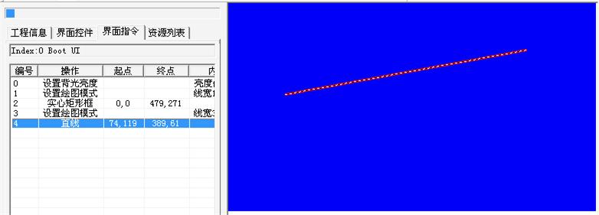

If you double-click a display instruction with the left mouse button, a modification dialog box for that instruction will pop up. You can modify the parameters of the instruction. For example, if you have an instruction to set the drawing color, a drawing color setting dialog box will pop up. If you have an instruction to draw a line or other drawing operation, a coordinate modification dialog box will pop up so that users can modify the starting point coordinates of the drawing operation.

For example, on the premise of the resource file previously operated, double-click the drawing line command added earlier, and a dialog box will pop up as follows:

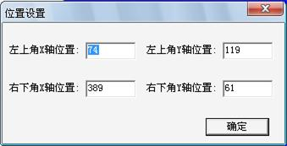

Modify the coordinates of the line as shown in the figure below:

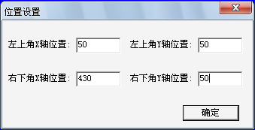

Click the "OK" button to modify the previous line drawn with the mouse as shown in the following figure:

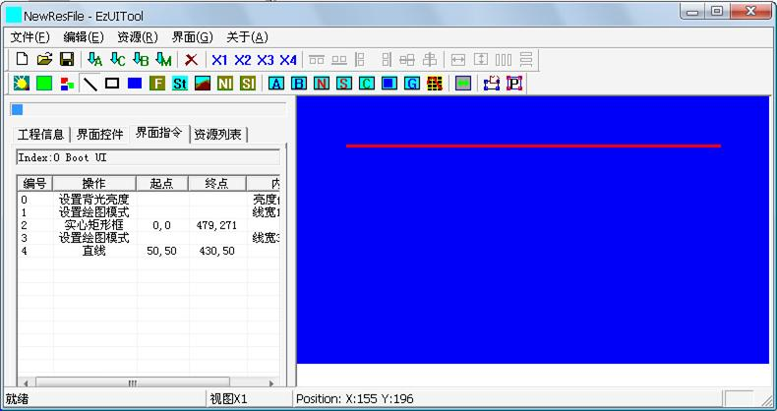

In addition, the way to modify the drawn graphics can also be realized by clicking the area modification tool button. First, select the modification instruction in the list of the "Interface Directive" tab, and then click the area modification tool button, and the interface will appear as shown in the following figure:

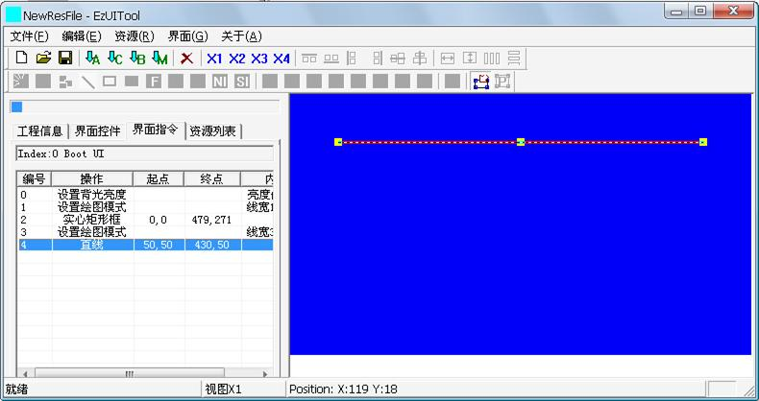

At this time, you can drag several reference points (shown as square focus in the figure) of the drawn graph in the display preview area to modify the drawn graph, or use the direction keys on the keyboard to change its position.

After the modification is completed, click  the area modification tool button in the toolbar to exit the area modification mode.

After the modification of drawing graphics is completed, the user can click the invalid area in the resource data display area to cancel the current selection instruction, so as to facilitate the addition of subsequent display operation instructions.

**Multiple selection:** Users can use the function key "Ctrl" in the list of "interface instructions" to select multiple display instructions, or they can also box multiple display instructions.

**Right-click menu:** Users can use the right mouse button to pop up a shortcut menu in the "Interface instructions" list, and select the corresponding menu item to realize the copy, paste, position adjustment and other operations of display instructions.

## image display

The prerequisite for image display is that the bitmap or Jpeg image resource to be displayed must be loaded into the resource file first. Click the image display instruction tool button in the toolbar, and a bitmap selection dialog box will pop up. Users can select the image resource to be displayed in it, as shown in the following figure:

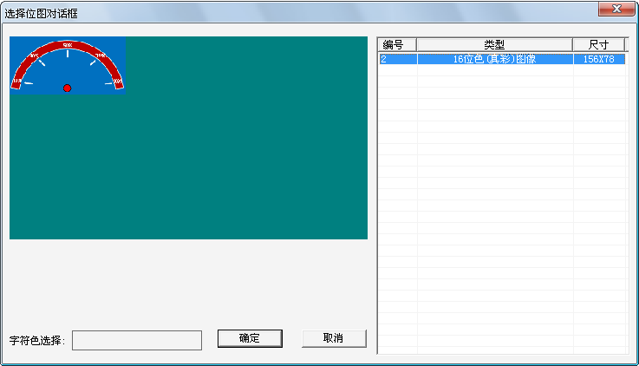

When selecting, the selected bitmap effect will be displayed on the left of the dialog box. Finally, click the "OK" button to enter the coordinate setting of the image display instruction, as shown in the following figure:

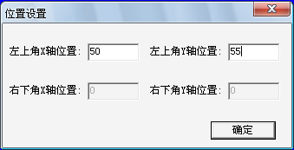

Set the upper left corner coordinate of the image display to "50,55", click "OK", you can complete the addition of the image display instruction, as shown in the figure below:

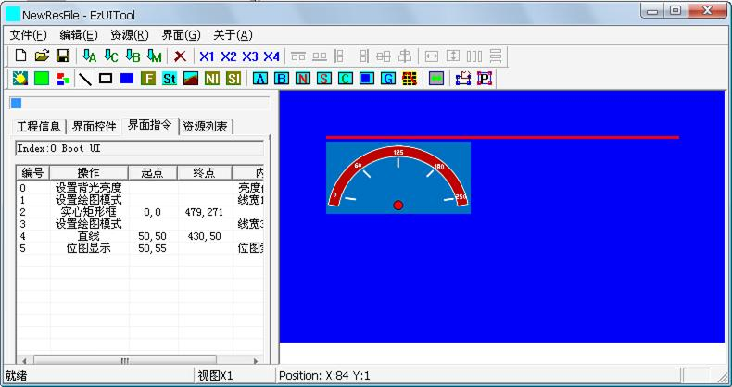

**Note: Only the EzUIH series modules support the display of Jpeg image resources, while other basic EzUI and streamlined EzUILet series can only display bitmap resources.**

## String is displayed

The display command of the string requires the user to set the font library first, including the selection of the font library and the setting of the character color. The font library setting command tool button in the toolbar can be clicked to open a font library setting dialog box, as shown in the following figure:

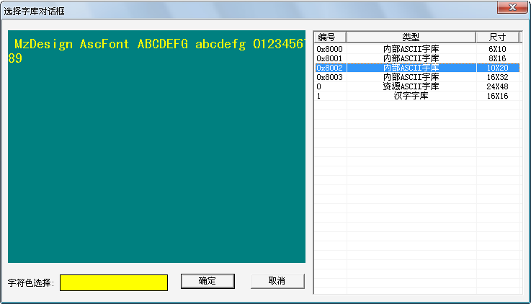

In the list on the right, click to select the font library. Then click on the color block to the right of "Character Color Selection" in the dialog box. In the pop-up color selection dialog, choose the character color. In the image above, select the 2nd ASCII font library inside the module, with the character color set to yellow; then click the "OK" button to complete the addition of the font library settings.

Note: The setting of ASCII Western font library and Chinese character font library should be carried out separately, but the character color set is the same function, and the last setting is taken as the standard.

In the same way, set the Chinese character library. Use the 16X16 Chinese character library loaded into the resource before use, and set the character color to yellow. After the setting is completed, the interface instruction list is displayed as follows:

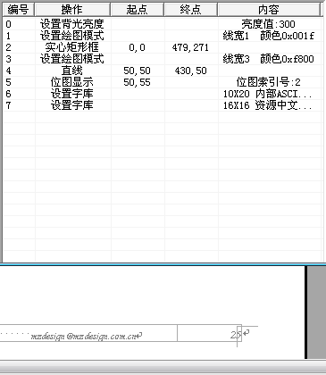

After setting up the font library, you can click the string display status settings tool button in the toolbar to put the tool into the string display operation state. At this time, you can use the left mouse drag in the display area to determine the area to be displayed, as shown in the following figure:

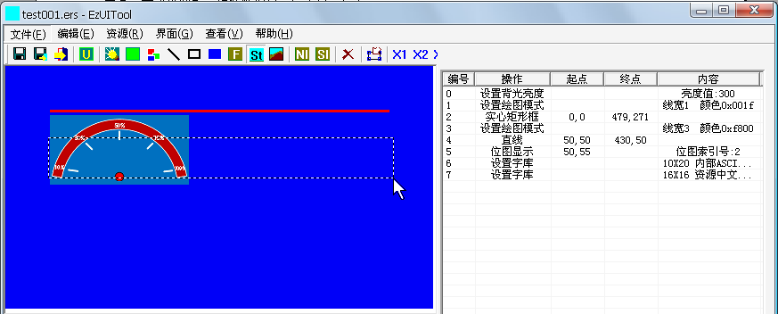

The box in the figure above is the area where the set string is displayed. At this time, release the left mouse button, and a dialog box will pop up, in which you can display and input the string, as shown in the figure below:

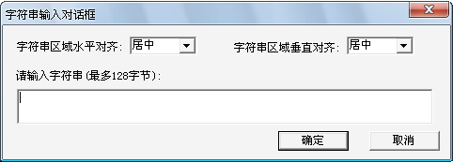

Select the string area. In this case, select horizontal and vertical alignment mode as centering. Enter the string "Welcome to use MzDesign TFT display module" in the string input area, and then click OK to complete the addition of the string display instruction.

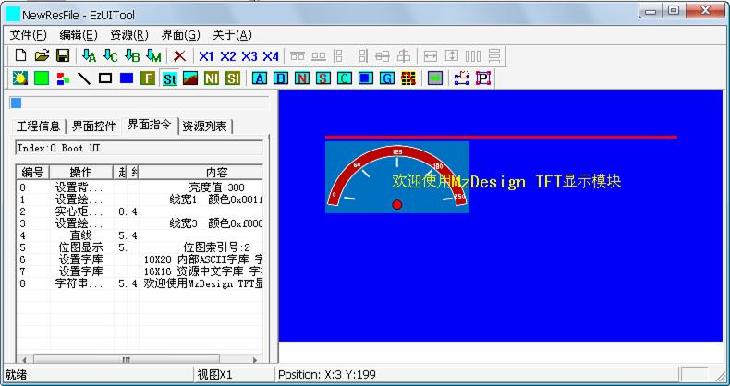

## General control resource Settings

The EzUI series module requires users to configure the corresponding common control resources in the interface if they want to use the function of populating the numerical input dialog box of the numerical control or the function of populating the string input dialog box of the string control.

The setting of the resource of the numeric input box can be clicked by clicking the "Numeric Input Box Resource Configuration" button, while the setting of the resource of the string input box can be clicked by clicking the "String Input Box Resource Configuration" button; here, the setting of the resource of the numeric input box is taken as an example:

Click the  tool button, a resource selection dialog box will pop up, in which you can select the value input box resource item to be used, as shown in the following figure:

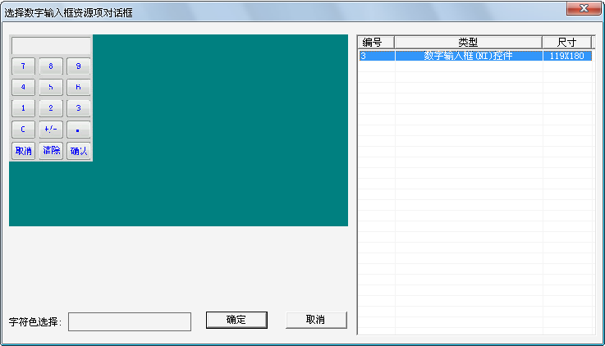

In the list on the right, select the required resource item, click the "OK" button, then enter the font library selection dialog box, as shown in the following figure:

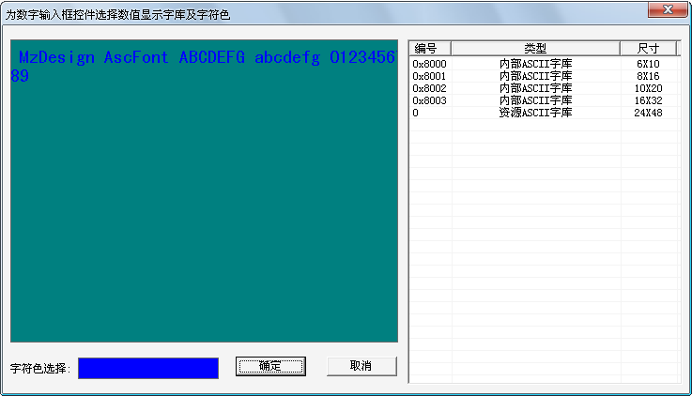

As with the previous font setting, set the font and character color for the selected value input box resource in the dialog box, and click "OK" to complete the setting.

## Save the resource file

After editing the interface, you need to save it.

Click the "Save Tool" button in the toolbar to save the edited interface data to a resource file and then save the resource file. If the previous resource file is newly created and has not been saved, a new file save dialog will pop up. Users can name the resource file to be saved (the basic EzUI series and enhanced EzUIH series modules only support English filenames) and specify its save path.

Here, save the interface data and resource files that have been edited previously. Then copy the resource files into the EzUI module (note the configuration of the resource files, such as screen pixel settings, which must match the module, and ensure there is only one resource file in the module's resource storage). Next, set the module to normal operating mode, reset or power on the module again. The module will display the previous interface with index number 0, as shown in the following figure:

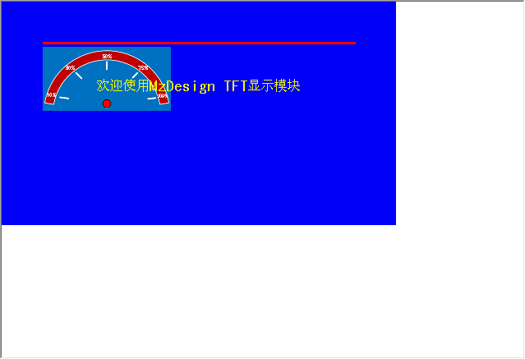

## Edit other interfaces

The user can edit other interfaces according to the method described above. Here, the interface indexed as 1 (previously named "Work UI1") is edited as shown in the following figure:

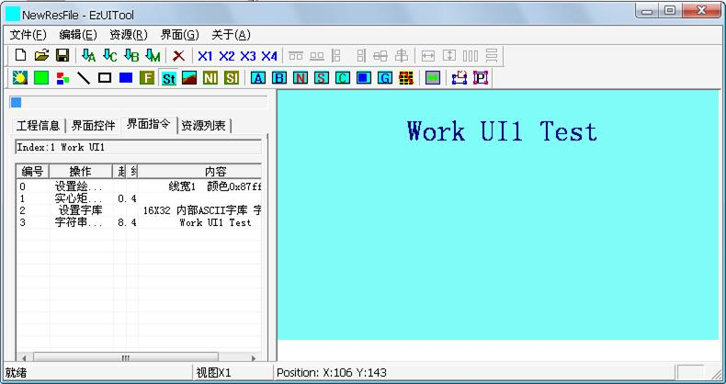

The interface indexed as 2 (previously named "Work UI2") is edited as shown in the following figure:

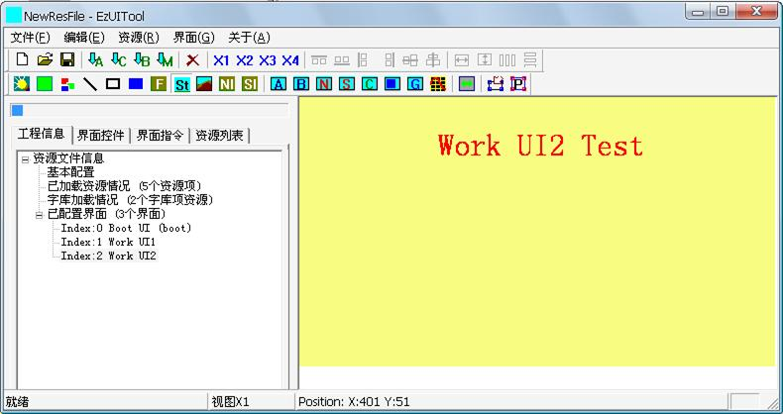

# Interface control Settings

Take the resource file of the resource item loaded in the previous chapter as an example, double-click "Boot UI" with the left mouse button, that is, the interface item with index number 0, enter the editing of the interface, and then switch to "Interface Controls" in the navigation TAB bar, as shown in the following figure:

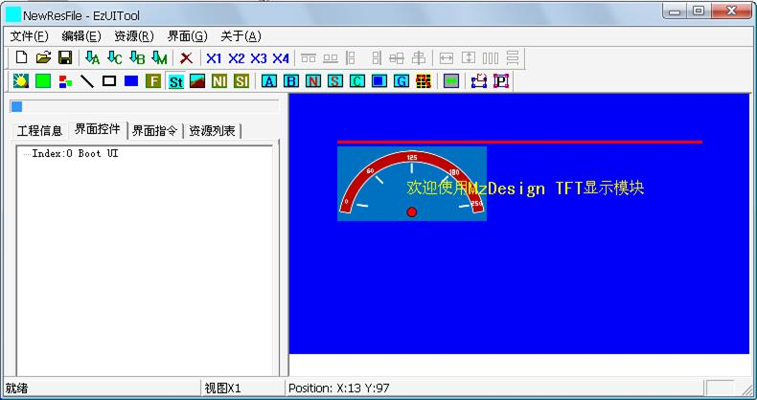

## Setting of the regional button control

The method for adding control settings is the same. First, in the interface control settings function, press the corresponding control setting status work button on the toolbar to put EzUITool into the control setting state. Then, use the mouse to drag and drop to determine the area of the control in the display area. When the mouse pops up, the control setting dialog box will appear. Complete the control settings in the dialog box.

In the interface 0 of the resource file previously edited and generated, press the "" area button control Setting Status Tool" button to set the tool software in the area button control setting state. Then, in the display area, hold down the left mouse button on the area where you want to set the control, and drag the mouse to another coordinate point in the area, as shown in the figure below:

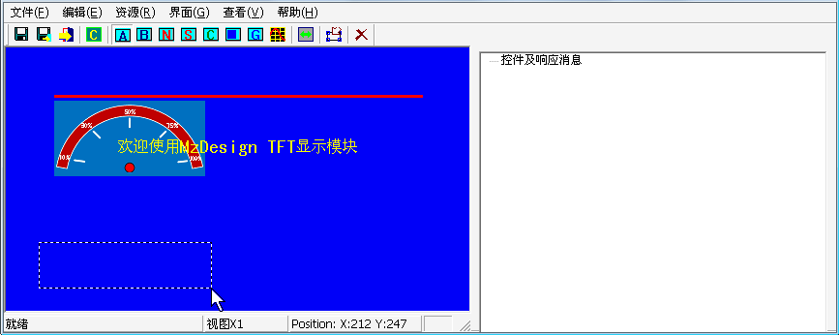

Then, release the left mouse button, and a regional button control Settings dialog box will pop up, as shown in the following figure:

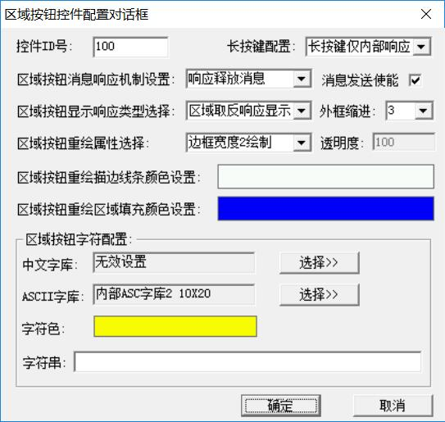

**Control ID:** The unique identifier of the control, which is automatically generated by the tool. The ID number of standard controls starts from 100.

**Message Sending Enable:** This setting is an enable switch for sending message data triggered by the area button control via the serial port. It defaults to checked, meaning that when the control triggers a message, it will send a message data packet (GUI service engine message data packet) through the module's serial port; if unselected, this control will no longer trigger the sending of message data packets. (Note: The basic version of EzUI series modules does not support this function)

**Long press configuration:**

This property is only valid for the EzUIH series and can be used to set the mechanism for long press message triggering of controls. The alternative options are as follows:

* Long press is not supported: indicates that the control does not support long press function;
* Long key is only internally responsive: it indicates that the long key message of the control is only used by the module's internal system to drive the control message, and will not continuously trigger the sending of the message data packet (through the serial port);
* Continuous message with long key: When the message sending enable is checked, it indicates that when the control is pressed for a long time, in addition to continuously triggering the message supply module to drive the control message internally, it will also continuously send the message data packet to the user MCU.

**Message response mechanism Settings:**

The attribute setting refers to the mechanism of setting the control to respond to touch events (touch version) or key message events (non-touch version) and return messages when the message sending enable is checked. The return object is the user MCU, which sends back to the user MCU through a serial interface in a specific data packet format; this configuration has three options:

* Response to press the message: indicates that the control only returns the message to the user MCU when pressed;
* Response release message: indicates that the control returns the message to the user MCU only when it is released;
* Response to press and release message: indicates that the control will return the message to the user MCU when pressed and released.

**Display the response type selection:**

This setting shows how the area button responds to touch events or key message events; the options are as follows:

* No response: indicates that the button in this area does not respond to the press, that is, no change is displayed;
* The outer frame width 1 inverted display: This indicates that when the button in this area is pressed, an inverted display will be performed with a rectangle of width 1 within the specified outer frame; (the area of the specified outer frame is formed by setting the padding value for the designated pixel points of the region button control, and the specified padding value is selected and set by "outer frame padding")
* The outer frame width 2~8 takes the reverse display: it indicates that when the button in this area is pressed, a rectangular box with a line width of 2~8 will be displayed in the specified outer frame;
* The region reverse response display: indicates that when the button in this region is pressed, the reverse display will be performed in the specified outer frame area.

**Frame shrinkage:**

The outer frame here refers to the "outer frame" of the area button control after it is scaled down relative to the actual defined area of the area button when the display response is shown. The value can be set to 0~8.

**Redrawing attribute selection:**

When the control is redrawn, it will draw the control according to the redraw property set. The redraw property options for the area button control are as follows:

* No redraw: the control will not be redrawn, which is equivalent to the control is hidden;
* Border width 1~8 drawing: The control will be drawn with a line width of 1~8 pixels, and the border line color will be redrawn according to the set control;
* 3D button shadow width 1~5: The control will be drawn with a line width of 1~5 pixels to make the control appear three-dimensional;
* Area fill drawing: When the control is redrawn, the control area will be drawn with the set control area fill color; and the transparency value of the fill color can be set during the fill, which makes the control appear semi-transparent.

**Transparency:** The value is set to 10~100. The smaller the value, the higher the transparency of the color block when the control is repainted to fill the area.

**Regional button character configuration:**

The area button, as a control of the control type, allows users to set strings for this control. It supports both Chinese and ASCII Western string characters. If you need to set strings within the control, you must configure the font library used for the strings, which includes selecting the Chinese font library and the ASCII Western font library; the character color displayed in the string can also be set.

Here, use the default configuration and set the string of the control to: "To Work UI1", then click OK to complete the setting.

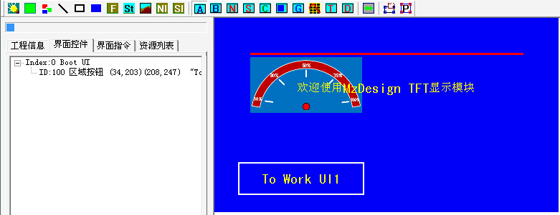

In the same way, create another area button control in the lower right corner with the string set to "To Work UI2", as shown below:

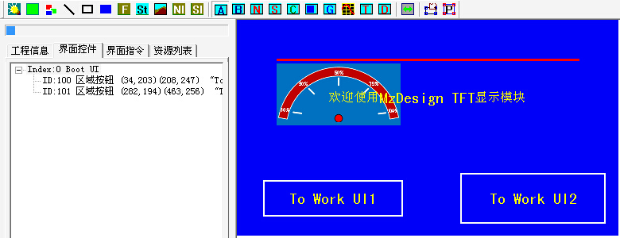

As you can see from the figure, two area button controls have been set up in the current interface, with ID numbers 100 and 101.

## Configure control messages

The GUI service engine of the EzUI series modules allows for configuring control messages for certain controls. These control messages can drive interface transitions or update data within controls through touch events (for touch versions) or key press event (for non-touch versions). The transmission and response operations of these messages do not require user intervention, enabling more flexible implementation of human-computer interaction functions as needed by users.

In EzUITool, to add configuration messages for a control, you first need to select the control on which you want to add the configuration message. Users can click and select the control from the tree list in the “”interface controls tab. After selecting, click the "Control Message Configuration Tool" button in the toolbar, and complete the corresponding configurations in the pop-up control message configuration dialog box.

In the previously edited resources, in the control setting function interface of interface 0, select the control with ID number 100, and then click “”a control message configuration dialog box will pop up, as shown in the following figure:

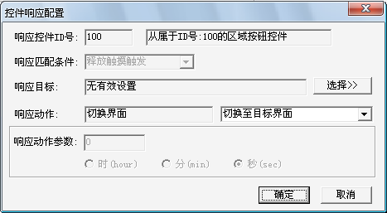

**Response control ID:** Indicates which control triggers the message of the control. Allows a control to generate multiple control messages.

**Response matching conditions:** indicates the conditions under which the message is generated by the control. The matching conditions that can be selected for the control messages triggered by different types of controls vary depending on the specific type of control.

**Response target:** This value indicates which control or interface is operated after the control message is generated. If the control is operated, this value indicates the ID number of the target control; if the interface is switched to display, this value indicates the index number of the target interface.

**Response action:**

Specifies the type of operation to be performed on the message of this control. The following options are available:

* Switch interface: indicates that after the message of this control is triggered, it will switch to the target interface index number set as "response target" in front;
* Reset the target control: indicates that after the message of this control is triggered, the data/value of the target control set in the "response target" indicator will be reset;
* Value addition 3 for target control: It indicates that after the message of this control is triggered, it will carry out data/value addition operation on the target control indicated by the "response target" set in front, and the value of the addition operation is determined by the value of the "response action parameter";
* Impairment 4 of target control: Indicates that after the message of this control is triggered, the data/value impairment operation will be performed on the target control indicated by the "response target" set in front, and the size of the impairment operation is determined by the value of the "response action parameter".
* Return previous interface: indicates that the control message is triggered and will be switched to the previous interface, which is also the previous interface that was switched into the current interface.
* Enable target control 1: Indicates that after the message of this control is triggered, the enabled operation will be performed on the target control indicated by the previously set "response target". If the target control is disabled and the display status is eliminated, the target control will be redrawn.
* **Disable target control 1:** Indicates that after the message of this control is triggered, the target control set in the "response target" indicator will be disabled. After the target control is disabled, it will not be allowed to display updates and respond to touch messages, but it will still remain displayed.
* **Disable and eliminate target control 1:** This indicates that after the message of this control is triggered, the "response target" indicator set in front will disable the target control and eliminate the display of the target control in the interface.
* **Use target control to set system RTC 2:** This indicates that after the message of this control is triggered, the target control (only time display control and date display control, and the control type must be "used to set module RTC system time") set in the previous setting will be used to update the RTC system time inside the module with the data.

**Note 1: This function is invalid for the EzUILet series.**

**Note 2: This function is valid for modules with built-in RTC clock.**

**Note 3:** If the target control is a string control, when adding to the target control, the ASCII code character corresponding to the value set in the response parameter will be added to the string control. Since the data of the string control is the string content, adding to it means appending the specified character to the end of the current string in the string control.

**Note 4:** If the target control is a string control, the response action will remove the last character from the current string content of the target control and refresh the display when the target control is reduced.

**Response action parameters:**

The response action parameters are configured differently according to the different target control types of the control message, which can be divided into the following cases:

* Unconfigurable cases: When the response action is "return to previous interface", "reset the target control", or **"use the target control to set the system RTC"**, this parameter cannot be set and does not need to be set;
* Configure a byte action parameter: The response action is "add value to the target control" or "subtract value from the target control", and the response target control type is a data control (such as numerical control, progress bar control, dial control, bitmap animation control), you can configure a byte action parameter;
* Configuration of floating-point action parameters: Response action is "add value to target control" and "subtract value from target control", and when the response target control type is a "value control" of floating-point type, you can check "set floating-point" and set the corresponding data;
* Perform addition or subtraction operations on the time display control: When the response action is "add value to target control" or "subtract value from target control," and the target control type is "time display control" used for setting the RTC system time of the module; allow setting the response action parameter value to 0~31, and can check the options for the hour, minute, and second (indicating the specific content of message-driven modifications in the control);
* Perform addition or subtraction operations on the date display control: When the response action is "add value to target control" or "subtract value from target control," and the target control type is a "date display control" used for setting the RTC system date; allow the parameter value of the response action to be set between 0 and 31, and enable the selection of the time display control options for year, month, and day (indicating the specific content modified by message-driven changes in this control).
* Perform value addition on string controls: The response action is "add value to the target control," and when the target control type is "string control," users can set a 1-byte response parameter. This setting allows for setting the parameter value directly as an 10-digit number; alternatively, by checking the single checkbox for "character input" and then directly setting the character (ASCII code), this is equivalent to entering the ASCII code value of that character.

Here, a control message will be configured for the area button control with ID number 100. When the area button control with ID number 100 is pressed, the display interface will be switched to the interface with index number 1. The configuration is as follows:

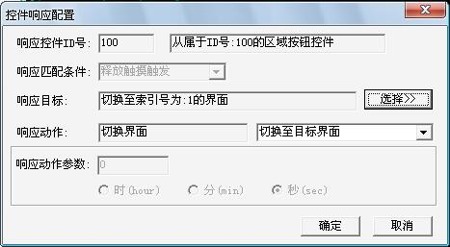

Click OK to complete the configuration of the control message. Use the same method to configure a control message for the control with ID number 101. After the control button with ID number 101 is pressed, switch the interface to the interface with index number 2.

After the configuration is completed, the resource data display area on the right of the EzUITool tool software is shown in the following figure:

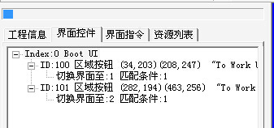

Similarly, using the method described above, create a region button control for interface 1 (named Work UI1) and configure the control message for it to switch the interface to the interface with index number 0, as shown in the following figure:

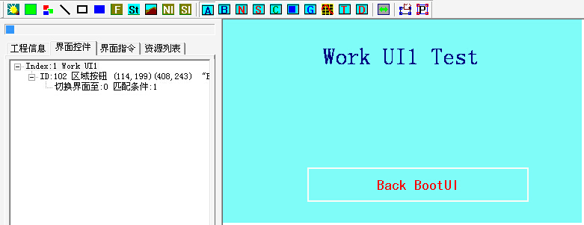

Create a region button control for the interface 2 (named Work UI2) and configure the control message for it. The control message is to switch the interface to the interface with index number 0, as shown in the following figure:

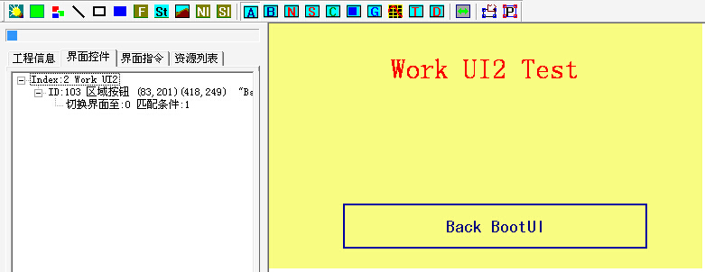

Save the previously edited interface data and resource files, then copy the resource files into the EzUI module, and then set the module to normal working mode, reset or power on the module again, the module will display the previous interface index number 0 display effect, as shown in the following figure:

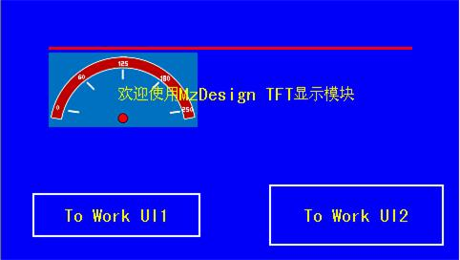

For example, in the interface shown above, if the user touches the button control of the display module ID number 100 (string set to "To Work UI1"), the response will be displayed on the screen as shown in the following figure:

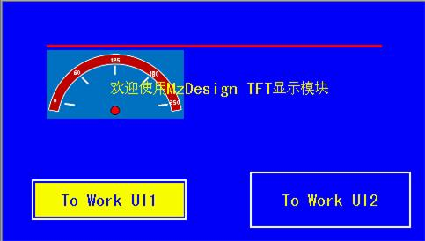

At this point, releasing the touch on the button control in the area triggers a touch event for the area button with control ID 100. This will trigger the control message previously configured for this control, which switches the display interface to the one with index number 1 (named "Work UI1"). The screen then shows the effect illustrated in the following figure:

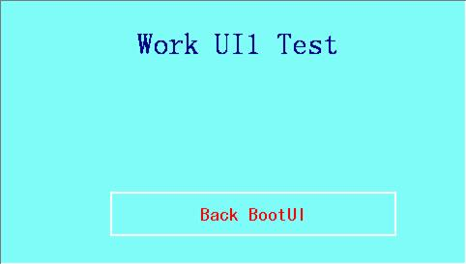

In the Work UI1 interface, if a user touches the button control with an ID number of 102, it will trigger the control message previously configured for this control. After the touch is released, it will return to the Boot UI interface. In the Boot UI interface, touching the button control with an ID number of 101 will also trigger a control message, switching the interface to the Work UI2 interface.

## Settings for other controls

* + 1. **Bitmap button control Settings**

The bitmap button control (BMPButton) is a button based on bitmap resources. It has many configurable properties and can achieve various display and response effects; this control supports control message configuration. In the EzUITool tool, the configuration screen of the bitmap button control is shown in the following figure:

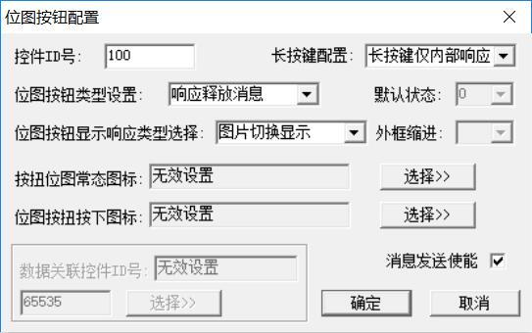

**Message Sending Enable:** This setting is an enable switch for message data triggered by the bitmap button control to be sent via the serial port. It defaults to checked, meaning that when the control triggers a message, it will send a message data packet (GUI service engine message data packet) through the module's serial port; if unselected, this control will no longer trigger the sending of message data packets. (Note: The basic version of the EzUI series modules does not support this function)

**Long press configuration:**

This property is only valid for the EzUIH series. You can set the mechanism for long press message triggering of controls here. The alternative options are as follows:

* Long press is not supported: indicates that the control does not support long press function;
* Long key is only internally responsive: it indicates that the long key message of the control is only used by the module's internal system to drive the control message, and will not continuously trigger the sending of message packets;
* Continuous message with long key: When the message sending enable is checked, it indicates that when the control is pressed with a long key, in addition to continuously triggering the message for the module's internal system to drive the control message, it will also continuously send the message data packet to the user MCU.

**Bitmap button type setting:**

The attribute settings for this item are similar to those for the message response mechanism of the area button control. The main focus is on setting up the mechanism for the bitmap button control to return messages when it responds to touch events or key press message events, provided that the message sending is enabled. However, the bitmap button control has two additional settings here. This configuration offers five options. It's important to note that in the following explanation, the control will only trigger the serial transmission of the message data packet when the message sending is enabled.

* Response to press the message: indicates that the control only sends the message to the user MCU through the serial port when it is pressed;
* Response release message: indicates that the control only sends a message to the user MCU through the serial port when the touch is released;
* Response to press and release message: it indicates that the control will send messages to user MCU through serial port when pressed and released;
* Ping-pong switch: indicates that the control is a status button, similar to the status switching button, and can be used to achieve the effect of a single button; the property of ping-pong switch, when the state changes, the control will send a message to the user MCU through the serial port.
* Ping-pong switch (single selection): indicates that the control is a status button, similar to the ping-pong switch. The only difference is that when this type of setting is set, the control only allows the user to switch from state 0 to state 1, but does not allow the user to switch from state 1 to state 0.

**Default state:**

When the control type is set to ping-pong switch and ping-pong switch (single selection) type, this parameter can be set, that is, to set the default state of the control after initialization.

**Display the response type selection:**

This setting is used to display the way in which the touch area responds to touch event key message events; the options are as follows:

* Bitmap switching display: indicates that when the control area is pressed, the bitmap button control configured with "pressed icon" bitmap will be switched and displayed;
* The outer frame width 1~8 takes the reverse display: it indicates that when the control area is pressed, a rectangular frame with a line width of 2~8 will be displayed in reverse display in the specified outer frame;
* The region anti-reflection response indicates that when the control area is pressed, the anti-reflection display will be performed in the specified outer frame area.
* Screenshot Switch Display: This feature is similar to the "Bitmap Switch Display" setting type, but it indicates that the normal icon and the pressed icon of the control will be based on a partial area of the selected bitmap. The selection of this area corresponds to the partial area of the bitmap set for the control relative to the display screen. Typically, bitmap materials the same size as the screen are used.

**Normal icon:**

The bitmap button control is a button control based on bitmap resources. At least one bitmap resource must be specified as the normal icon of the control, which can be selected from the bitmap resource loaded into the resource file; when the control is redrawn, the bitmap will be displayed.

**Click the icon:**

The icon setting of the bitmap button control is optional, but if the display response type is selected as "bitmap switch display" or the bitmap button control type is selected as "ping-pong switch", this configuration must be enabled, and the bitmap size of the pressed icon must be the same as that of the normal icon.

**toggle switch:**

When the bitmap button control is set as a toggle switch, you need to specify the normal state of the control and the icon bitmap resource when pressed. At this point, the control acts like a switch with two states: 0 and 1. When the state is 0, it displays the normal icon; when the state is 1, it displays the pressed icon. The control's state will change when it receives valid touch events or key message events. For example, in a touch-based module, after the control has been redrawn and its state is 0, pressing the control area and releasing the touch within that area will switch the control's state to 1, displaying the pressed icon. Users can also set the control's state through commands, which will update the display based on the actual situation, and can also read the control's state via commands.

**Data association control ID (only EzUIH is allowed):**

When the bitmap button control property is set to ping-pong switch (including single selection), the bitmap button control will have a value (state), and the ID number of the data associated with the control is allowed to be set.

**Note:** Data association control ID setting. This setting allows data synchronization between different controls (including different types of controls). After effective configuration, data synchronization can occur between controls. For example, if Control A is set to associate with Control B, Control B associates with Control C, Control C associates with Control D, and Control E associates with Control C (note that it is Control E associating with Control C), then Controls A, B, C, D, and E will all be in a data-associated state. When users touch and input values or states into any of these controls on the module, or set values or states for any of these controls via a serial port, the values (or states) will be synchronized and updated using Controls A, B, C, D, and E.

The setting of the data associated control ID number allows multiple associations and allows different types of controls in different interfaces to be associated with data, which can greatly reduce the number of data packets between users and modules and improve the communication efficiency of users MCU.

* + 1. **Value control Settings**

The numerical control (Number\_Ctrl) is a control that can input and display the user's set value. It has many properties to configure, and can realize many display and response effects; this control does not support the configuration of control messages, but allows other controls to control it.

The numerical input function of the numerical control requires the user to first configure the numerical input box resource in the interface instruction, that is, select the appropriate numerical input dialog box.

In the EzUITool tool, the configuration screen of the numerical control is shown in the following figure:

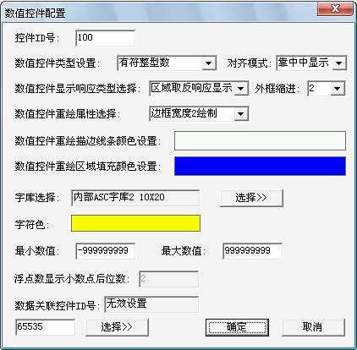

**Value control type setting:** The value control can be set as unsigned integer, signed integer, floating point number, and bit display of unsigned integer.

**Alignment mode:** that is, the alignment mode in which the value is displayed in the defined control area. Vertical and horizontal alignment modes can be set, and the appropriate alignment mode can be selected from the drop-down list in two directions.

**Font selection:** When the numeric control displays the value, it is displayed in ASCII Western characters. The user must specify the font used by the control and the character color.

**Minimum value, maximum value:** The numeric control can set the maximum and minimum values that the control allows to be entered. When the input value exceeds the set range, the input will not take effect.

**Floating point number shows the number of decimal places:** When the value type of a numeric control is a floating point number, you can set the number of significant digits after the decimal point; additionally, when the numeric control type is "unsigned integer display by bit," this setting allows the value to be displayed according to the set number of bits.

**Data association control ID (only EzUIH is allowed):**

The numerical control allows you to set the data associated with the control ID number.

* + 1. **String control Settings**

The String control (String\_Ctrl) is a control that can input strings and display user-set strings. It has many properties to configure and can achieve many display and response effects; the control does not support control message configuration, but allows other controls to control it.

The string input function of the string control requires the user to configure the string input box resource in the interface display operation instruction preset, that is, select the appropriate string input dialog box.

In the EzUITool tool, the configuration screen of the string control is shown in the following figure:

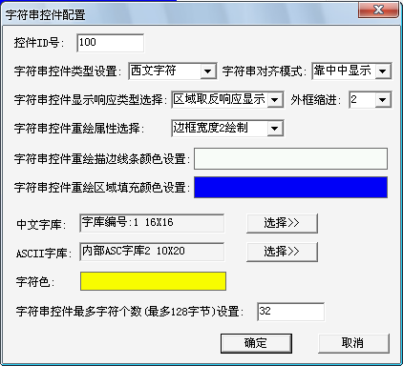

**String control type setting:** The string control can be set to numeric symbols, Western characters, and Chinese and English characters. In fact, it is equivalent to configuring the character type that the control allows to input when entering a string.

**Maximum number of characters:** Users can set this value to limit the number of characters (bytes) entered.

String controls are similar to numeric controls and will not be described here.

* + 1. **Set the drop-down selection control**

The drop-down selection control (Combox\_Ctrl) is a preset control that allows you to select preoptions by touch or button message. Up to **50** preoptions can be preset, and each preoption can be described with a string of up to 25 bytes.

The drop-down selection control has a variety of properties that can be configured and can achieve a variety of display, event response effects; the control supports control message configuration, but also allows other controls to control it.

The configuration dialog box of the drop-down selection control in EzUITool tool is shown in the following figure:

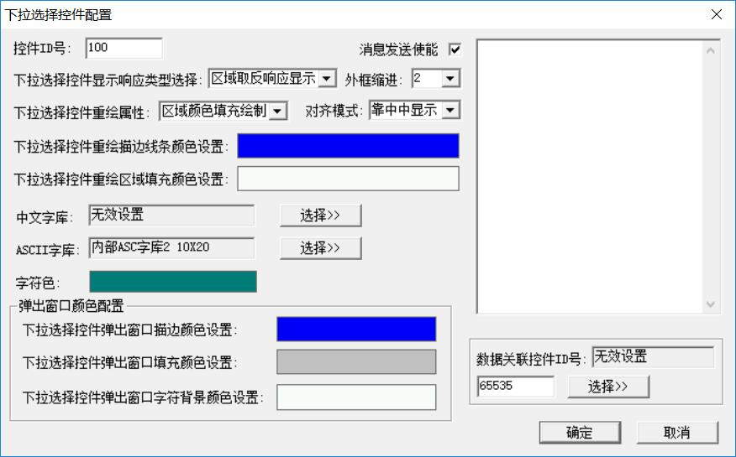

Most of the properties of the drop-down selection control are similar to those described above, but only the differences are explained here.

When displaying the response type selection, there is an option called "No Response (Do Not Allow Input)." When the control selects this attribute, it does not allow touch or button message responses. This means that the control cannot be selected on the touchscreen or its selection cannot be changed through button message events. At this point, the control will only display the currently selected item, which can be set by the user using appropriate commands.

**Color configuration of pop-up window:**

This field allows you to set the properties of the pop-up window, including: window outline color, window fill color, and character background color within the window. However, this is only valid for modules with touch versions.

To the right of the Settings dialog, there is a large text input box where you can enter the text description of the preset option. Multiple options are entered on the computer by pressing "Ctrl+Enter" to change line, and each line represents the text description of a preset option. Each line supports a maximum of 25 bytes of string.

**Data association control ID (only EzUIH is allowed):**

The drop-down selection control allows you to set the data associated with the control ID number.

* + 1. **Progress bar control Settings**

The progress bar control (Process\_Ctrl) is a display-only control that presents user data in the form of a progress bar.

The configuration dialog box of the progress bar control in EzUITool tool is shown in the following figure:

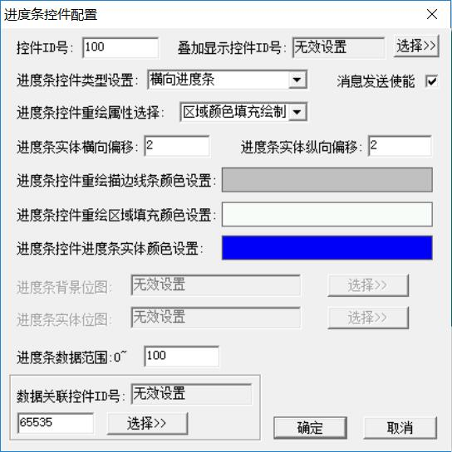

**Type Settings:** You can select a horizontal or vertical progress bar. The horizontal progress bar control increases from left to right, and the vertical progress bar control increases from bottom to top.

**Redrawing attribute selection:**

The progress bar control can select a variety of redraw properties, the options are as follows:

* Border line width 1~8 drawing: The control will be drawn with a line width of 1~8 pixels, and the border line color will be redrawn according to the set control;
* Area fill drawing: When the control is redrawn, the control area will be drawn with the set control area fill color.
* Background layer redrawing: When the control is redrawn, the display of the background layer will not be overlaid, and when the progress bar updates to display the position of the progress bar, the progress bar will be drawn on the display content of the background layer.
* Partial screenshot of bitmap redrawing: When this property is selected, the user only needs to set the "progress bar background bitmap" and the "progress bar entity bitmap." The control will use a partial area of the selected bitmap as the background for the control and as the drawing material for the progress bar entity. The partial area is determined by the relative position of the control on the screen; generally, a bitmap that matches the screen size is chosen.
* Bitmap redrawing: When this property is selected, the user only needs to set "progress bar background bitmap" and "progress bar entity bitmap". The control will use the selected bitmap resource item to draw the progress bar. The bitmap resource item used to draw the progress bar control must be of the same size.

**Horizontal offset of progress bar entity:** This setting determines the horizontal offset of the progress bar relative to the set control area in pixels.

**Vertical offset of progress bar entity:** This setting determines the vertical offset of the progress bar relative to the set control area in pixels.

**Redrawing stroke color Settings:** This setting can configure the border line color of the progress bar control.

**Redrawing area fill color setting:** This setting can configure the overall background fill color of the progress bar control.

**Progress bar entity fill color setting:** This setting determines the color of the progress bar entity.

**Progress bar data range:** This setting determines the maximum value of the progress bar entity when it is displayed at full value. The control will use this value as a reference to display the current position of the progress bar entity. When the current value of the control exceeds this setting, the progress bar control will display full value.

**Data association control ID (only EzUIH is allowed):**

The progress bar control allows you to set the ID number of the data associated with the control.

**Overlay display control ID:**

The progress bar control allows setting a component to display on top of it. The types of components that can be set include numeric controls or string controls. When the overlay is applied, only the font configuration, character color, and character alignment settings for the component displayed on top of the progress bar control are valid. It is required that the control area of the numerical or string control being overlaid must be entirely within the area of the progress bar control.

The numerical or string controls displayed in the overlay will not be able to receive touch input, and when the overlay progress bar control is controlled to hide, the overlay controls will also be hidden.

* + 1. **Waveform control Settings**

The waveform control (WaveForm\_Ctrl) is a display-only control that presents user data in the form of waveforms. In the same waveform control, up to four waveforms can be updated and drawn; each waveform can be set individually to its own waveform color.

The configuration dialog box of the waveform control in EzUITool tool is shown in the following figure:

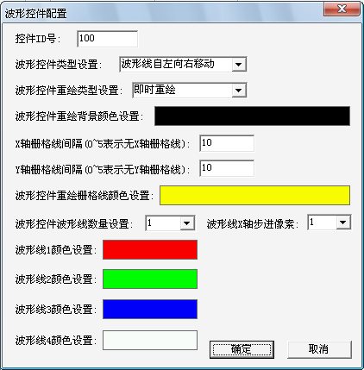

**Control type Settings:**

The waveform control allows the direction of movement of the waveform line to be set. There are two options:

* The waveform line moves from left to right: when the waveform is updated and displayed, new data will be added from the left side of the control. If the waveform has been displayed full of the control, the waveform line will be moved to the right;
* The waveform line moves from right to left: When the waveform is updated, new data will be added from the right side of the control. If the waveform is already full of the control, the waveform line will be moved to the left.

**Redrawing type Settings:**

There are two options for this setting:

* Instant redraw: indicates that the waveform control will automatically refresh the waveform display immediately after receiving new data from the user;
* User command control redrawing: It indicates that the waveform control does not automatically refresh the waveform display after receiving new data added by the user, but pushes the data into the buffer. After the user sends the waveform redrawing command, the waveform control will refresh the waveform display.

**Grid line spacing:**

Waveform control supports the display of grid lines for waveform controls. The vertical and horizontal grid lines are set similarly, and the corresponding grid lines will not be displayed when the value is less than or equal to 5; the value is set in pixels.

**Grid line color Settings:**

This setting determines the color of the grid lines of the waveform control, and the grid lines of the control are drawn with a line width of 1 pixel.

**Waveform control waveform line related Settings:**

A maximum of 4 waveform lines are allowed, and the color of each waveform line can be set separately. The default waveform line in the system will draw the waveform curve with a line width of 2.

The X-axis and Y-axis of the waveform control are both in pixels, that is, the range of the X-axis and Y-axis corresponds to the actual area of the control.

Waveform X-axis step value settings: By default, the waveform control has a step value of 1 pixel on the X-axis. For example, if you set a control with an X-axis starting coordinate of 10 and an X-axis endpoint (right side) coordinate of 109, the X-axis range of the waveform control is 100 pixels. When the step value is set to 1, it means that there are 100 data points in the waveform line within the display area of the control. If the step value is set to 2, then there are 50 data points in the waveform line within the display area of the control.

* + 1. **Bitmap animation control Settings**

The bitmap animation control (Gif\_Ctrl) is a dynamic image display control based on bitmap resources. It has many configurable properties and can realize the animation display effect or bitmap state display effect; this control does not support touch events, but allows to receive control messages.

In the EzUITool tool, the configuration screen of the bitmap animation control is shown in the following figure:

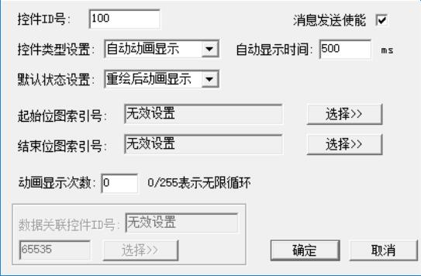

**Control type Settings:**

The bitmap animation control supports three types of Settings, as follows:

* Automatic Animation Display: When the control is set to this type, the control has two states: stopped and dynamic display. In the stopped state, the control displays the first bitmap indexed by the initial bitmap index. When the control is in dynamic display mode, it switches between bitmaps at intervals set by the "automatic display time," sequentially displaying bitmaps from the "initial bitmap index" to the "end bitmap index."
* Static and Dynamic Display: When the control is set to this type, it also has two states, namely the static state and the dynamic display state. When the control is in the static state, it will display the first bitmap pointed to by the "Start Bitmap Index" that has been set. However, when the control is in the dynamic display state, it will switch between bitmaps at intervals specified by the "Auto Display Time," sequentially displaying bitmaps from the "Start Bitmap Index" to the "End Bitmap Index."
* Full directive switch: When the control is set to this type, the state of the control will indicate the number of the bitmap displayed by the control. The size of the number is determined by the number of bitmaps between the "start bitmap index" and the "end bitmap index"; users can set the state of the control through commands to switch the bitmap displayed by the control.

**Automatic display time:**

The setting of this parameter is only valid when the bitmap animation control is set to "Automatic Animation Display" and "Static Dynamic Display" types, indicating the time interval of the control when the bitmap display is dynamically switched. The unit is milliseconds (ms), and the minimum value allowed to set is 200ms, and the maximum value is 2000ms.

**Default Settings:**

This parameter sets the default state of the control after system initialization. The value is set according to the type of the control.

* Automatic animation display: The control will allow you to set one of two default states, which are: redraw animation display and stop display after redraw, which means the default state of the control after initialization; Of course, users can also control the current state of the control through instructions, that is, the dynamic/stopped state of the control;
* Static and dynamic display: The control will allow you to set one of two default states, which are: static after redrawing and dynamic after redrawing, which means the default state of the control after initialization; of course, users can also control the current state of the control by command, that is, the dynamic/static state of the control;
* Complete instruction switching: The default state of the control indicates the number of bitmaps that the control displays by default after initialization. The size of the number is determined by the number of bitmaps between "start bitmap index" and "end bitmap index"; users can set the state of the control through instructions to switch the bitmap displayed by the control.

**Starting bitmap index:**

This setting determines the starting index number of the bitmap in the resource file for the bitmap configured by the bitmap animation control, requiring that the starting index number be less than the "end bitmap index".

**Ending bitmap index:**

This setting determines the ending index number of the bitmap in the resource file for the bitmap animation control, requiring that this starting index be greater than the "starting bitmap index." The number of bitmaps between the starting bitmap index and the ending bitmap index is the number of bitmaps configured for the control, or frame count.

**Number of animation displays:**

The setting of this parameter is only valid when the bitmap animation control is set to the "Automatic Animation Display" type. This parameter determines the number of times the animation will display. When its value is 0 or 255, it indicates infinite loop display; when set to other values, it specifies the number of dynamic displays. Once the number of display loops reaches the set value, the bitmap animation control will send a control message internally within the GUI service engine, which can be used to drive interface switching and other operations (this function is generally used for opening animation displays). If the enable checkmark for sending control messages is selected at this time, it will also trigger the serial transmission of message data packets.

**Data association control ID:**

When the bitmap animation control property is set to an option other than "Automatic Animation", you can set the ID number of the data associated with the control.

* + 1. **A time display control**

The Time Display Control (TimeDisCtrl) is a control that displays the built-in RTC clock or user-specified time information in a common time display mode. It has multiple configurable properties and can achieve multiple display effects.

If the time display control wants to display the time of the built-in RTC real-time clock in the module, the module should have the built-in RTC real-time clock function. Users should confirm whether the module used has the RTC real-time clock function when using it.

In the EzUITool tool, the configuration screen of the time display control is shown in the following figure:

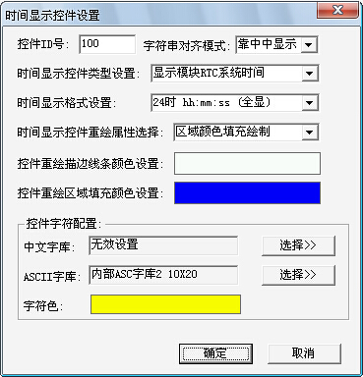

Some of the properties of the time display control are similar to those of the string display control. I won't go into detail here, but I'll just describe the unique properties of the time display control.

Control type setting: The control can be set to "display the RTC system time of the module" or "display the time specified by the user".

* Display module RTC system time: This type of setting indicates that the control gets the current time from the built-in RTC real-time clock of EzUI module for display; at this time, users are not allowed to update the control by writing instructions through the control value;
* Display the time specified by the user: This type of setting indicates that the control displays the time information written to the control by the user through instructions;
* Used to set the RTC system time of the module: This type of setting indicates that the control can accept the control message to modify the data, and can update the modified time to the built-in RTC real-time clock of the module (triggered by the control message).

Time display format: This setting determines the format in which the control is displayed, including various display styles such as 24-hour or 12-hour display.

* + 1. **Display the date control**

Date display control (DateDisCtrl) is a module that displays the built-in RTC date or user-specified date information in a common date display mode. It has multiple properties to configure and can achieve a variety of display effects.

Date display control If the module needs to display the date of the built-in RTC real-time clock, the module should have the built-in RTC real-time clock function. Users should confirm whether the module used has the RTC real-time clock function when using it.

In the EzUITool tool, the configuration screen of the date display control is shown in the following figure:

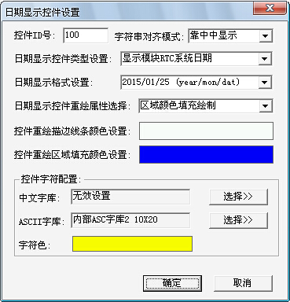

The properties of the date display control are similar to those of the time display control, so they will not be described in detail here.

* + 1. **The dial displays controls**

**The dial display control is a component that uses the background image of the dial as its base and indicates values by rotating a pointer clockwise around the center point. The dial background image is a bitmap resource. The dial pointer can be set to draw in straight lines or rotate images, achieving various display effects. This control does not support message configuration but allows other controls to control it. Note: This control is only supported by the EzUIH series modules.**

In the EzUITool tool, the configuration screen of the dial display control is shown in the following figure:

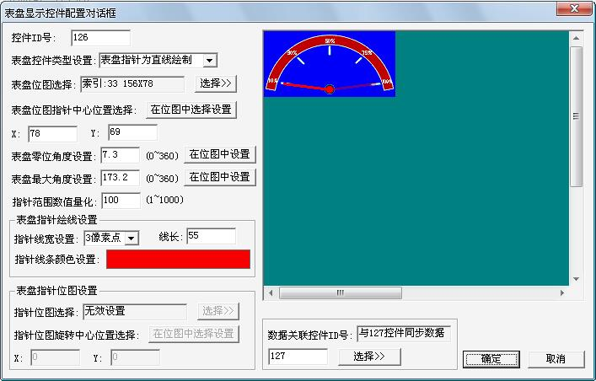

Clock face control type setting: the control can be set to draw the clock face pointer as a straight line or the clock face pointer as a bitmap resource;

* The dial pointer is drawn as a straight line: This type indicates that the dial pointer is drawn as a straight line determined by the user's configured line width, line length and drawing color when the dial display control is displayed. The example in the figure above is the dial pointer drawn as a straight line type.
* The dial pointer is a bitmap resource: This type indicates that the dial display control is displayed using a bitmap resource specified by the user.

Tablet bitmap selection: Click the button on the right to pop up the bitmap resource selection dialog box, where users can select the bitmap resources loaded into the resource file as the background bitmap of the tablet.

**Tablet map pointer center position selection:**

This setting determines the pointer rotation center point of the dial display control to be located at the position of the dial background bitmap. Clicking the right button allows you to select the offset position of the pointer center in the dial background bitmap by clicking and selecting in the display area on the right side of the dialog box, or you can directly input the coordinate points in the X and Y axis settings edit boxes below.

**Zero Angle setting of dial:**

The dial display control sets the zero position Angle. You can directly click the button on the right side to perform visual operation Settings in the display area on the right side of the dialog box, or directly enter the value of the zero position Angle in the edit box. The value range is 0~360.

**Maximum dial Angle setting:**

The dial display control sets the maximum Angle. You can directly click the button on the right side to perform visual operation Settings in the display area on the right side of the dialog box, or you can directly enter the value of the maximum Angle in the edit box. The value range is 0~360.

**Pointer range value quantization:**

The starting position of the pointer on the dial display control is determined by an angle value. To achieve better numerical representation, this value can be set to quantize the angle range of the control into integer values. After quantization, the numerical value of the dial display control will correspond to the quantized angle range. For example, in the figure above, if the zero-degree angle value is set to 7 and the maximum angle value is 174, with a quantization value of 100, then the angle range of the dial display control is from 7 to 174 degrees. When the current value of the dial display control is 0, it indicates that the pointer is at the zero position (7 degrees). For every 1 increase in the value, the pointer rotates 1.67 degrees clockwise.

**Clock face pointer drawing line setting:**

When the dial display control is set to the straight line drawing type, the settings in this area are valid.

Pointer line width setting: You can select the line width of the straight line when drawing with the pointer.

Pointer line length setting: the appropriate pointer line length can be set according to specific needs, in pixels.

Pointer line color setting: you can set the appropriate pointer color according to the specific needs. Click the color block on the right, and a color selection dialog box will pop up.

**Clock pointer position setting:**

When the dial display control is set to bitmap resource type, the settings in this area are valid.

Pointer bitmap selection: Click the button on the right to pop up the bitmap resource selection dialog box, from which users can select the bitmap resources loaded into the resource file as the pointer bitmap of the dial.

When creating pointer bitmaps, users should pay attention to the following points:

1. In addition to the effective pointer line area of the bitmap image, the background color should be different from the pointer line color. In this way, when the pointer bitmap is displayed, the areas outside the pointer line will be automatically cleared and not displayed. However, it is better for the background color to be close to the background color of the dial background bitmap;
2. Bitmap images should be created with the pointer rotation Angle set to 0.

The following figure is an example of a pointer bitmap image:

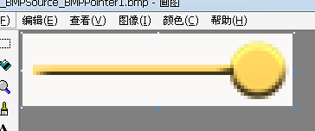

As you can see, except for the pointer line in the yellow area, the rest of the image is selected in a different white color. This way, when the control is displayed, the module will automatically clear the edge area and display the following figure:

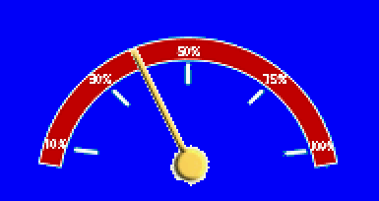

Pointer bitmap rotation center position selection:

You can click the button on the right to use the mouse click selection pointer bitmap rotation center point in the display area on the right of the dialog box, or you can also directly enter the value through the two edit boxes below to set.

**Data association control ID (only EzUIH is allowed):**

The dial display control allows you to set the data associated with the control ID number.

* + 1. **Slider control**

The slider control (SliderCtrl) provides a simple and quick numerical setting class component, supporting both horizontal and vertical sliding types. It can be drawn by the system or using bitmap resources set by the user; during use, the slider control allows users to tap the touch area to set values (or positions), and also enables holding down after pressing to drag and slide the block to adjust values; the capacitive touch version offers an excellent module experience. This control does not support configuration of control response messages but allows other controls to control it. **Note: This control is only supported by the EzUIH series modules.**

In the EzUITool tool, the configuration screen of the slider control is shown in the following figure:

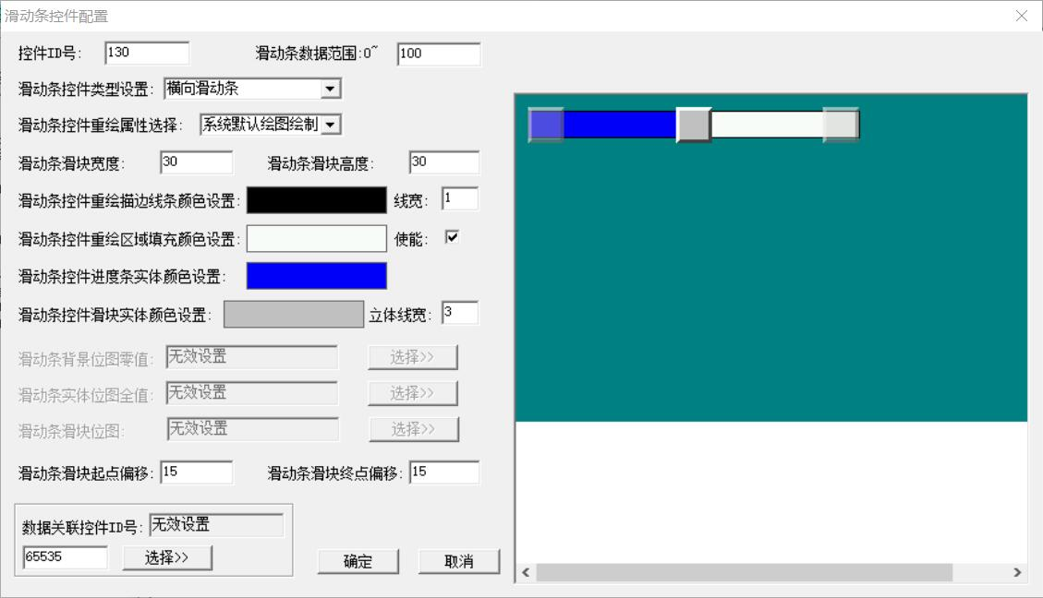

**Slider control type setting:** The control can be set as a horizontal slider or a vertical slider. When creating a new slider control in the tool, the tool will set the default horizontal and vertical properties according to the width and height ratio of the selected area;

Slide strip control redrawing attribute selection: the control can be set to system drawing or table bitmap resource drawing;

* System default drawing: This type indicates that when the control is displayed, the background of the slider, the entity progress of the slider and the sliding block are determined by the user's configured line width and drawing color. The example in the figure above is the system default drawing type.
* Bitmap Material Drawing: This type indicates that when the control is displayed, its background, entity progress, and slider are all drawn using bitmap resources from the resource items. It's important to note that when updating the bitmap material for display, the four corners of the bitmap will have their color data extracted. If all four points have the same color, it is considered a missing color (meaning that pixels with the same color as the missing color will not be displayed).

**Slider width:** When drawing controls using the default drawing of the system, this setting can redefine the width (X-axis) size of the slider. After updating this value, clicking other Settings areas in the dialog box will update the display effect corresponding to the current configuration in the effect display area on the right;

**Slider height:** When using the system default drawing to draw the control, this setting can redefine the height (Y axis) size of the slider. After updating this value, clicking other Settings areas in the dialog box will update the display effect corresponding to the current configuration in the effect display area on the right;

**Redrawing stroke line color settings:** When the control's redrawing property is set to system default drawing, the control will use the line width value set on the right side in pixels and draw the control border background using the redrawing line color; if the stroke line width is set to 0, it means the control does not draw a stroke, making the stroke line color meaningless; clicking on the color block with the mouse will pop up a color setting dialog for selection and configuration;

**Re-drawing outline width:** When the control redrawing property is set to the default drawing of the system, this item can set the value of 0~8, indicating the outline width when the control background is redrawing;

**Redrawing area fill color setting:** When the control redrawing property is set to the system default drawing, this item can set the background color of the control area; if the "enable" hook is selected on the right, the control will be displayed with the set color to fill the control area, which is the background of the control;

**Progress bar entity color setting:** When the control repaint property is the system default drawing, this item can set the color of the progress bar entity of the control, similar to the progress bar control;

**Slider entity color setting:** When the control redraw property is set to the system default drawing, this item can set the slider fill color,

**Solid line width:** When the control redraw property is set to the system default drawing, this item can set the solid effect line width of the slider. When its value is 0, it indicates that the solid effect is not used;

**Background bitmap:** When the control redrawing property is bitmap material drawing, click the button on the right to pop up the bitmap resource selection dialog box, users can select the bitmap resource loaded into the resource file as the background bitmap of the control;

**Entity bitmap:** When the control repaint property is bitmap material drawing, the user can select the bitmap resource loaded into the resource file as the progress bar entity bitmap of the control;

**Slider bitmap:** When the control redraw property is bitmap material drawing, the user can select the bitmap resource loaded into the resource file as the slider bitmap of the control;

**Slider Origin Offset:** The offset in pixels of the slider control when it is at zero value relative to the control's starting point (left for horizontal, bottom for vertical). This is typically set automatically by the system based on the size of the control's slider, but users can also modify this value themselves. After modifying this setting, you can see the corresponding changes in the effect diagram on the right side of the dialog box;

**Slider End Offset:** The offset in pixels from the zero value of the slider to the end point of the control (right for horizontal, top for vertical). This is typically set automatically by the system based on the size of the control's slider, but users can also modify it. After adjusting this value, you can see the corresponding changes in the effect diagram on the right side of the dialog box;

**Slider data range:** This setting determines the maximum value of the slider entity in the progress bar when it is displayed at full value. The control will use this value as a reference to display the current position of the slider entity. When the current value of the control exceeds this setting, the control will display full value.

**Data associated control ID (only EzUIH is allowed):** The slider control allows you to set the data associated control ID of the control.

**Bitmap material settings for creating slider controls:**

When using bitmap material to display the slider control, it is required that the size of the background bitmap is the same as that of the entity bitmap; and the slider bitmap should not be too small, too small is not easy to click or move the slider when setting the touch.

When the image materials used by controls are displayed, they will default to being shown as a missing color. The module will obtain the pixel color values of four points at the corners of the image. If all four points have the same color, it will be recognized as a missing color. Consequently, when displaying the bitmap, the material points that match the missing color will not be shown. Therefore, when creating bitmap materials, the following should be noted:

In addition to the effective area of the bitmap image, the background color different from the effective area should be used. In this way, when the bitmap is displayed, the areas outside the effective area will be automatically cleared and not displayed. However, it is better for the background color to be close to the background color of the dial background bitmap.

The following three bitmap images are examples of bitmap images that will be used for background bitmap, entity bitmap, and slider bitmap:

Slider_W_Back_L

Slider_W_Pr_L

Slider_W_Sl_L

The following figure shows the display effect in the control configuration dialog box:

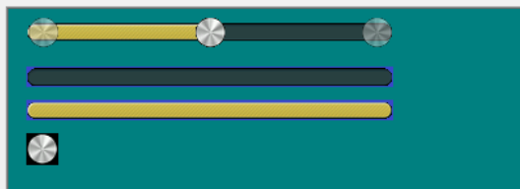

The transparent blur on both sides of the figure shows the zero value and full value positions of the control slider.

The following figure shows the display effect of the module in the interface:

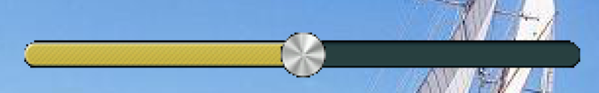

* + 1. **QR code display control**

The QR Code Display Control (QRCoderDisCtrl) is a display control that can convert strings preset by users or sent in real-time by microcontrollers into QR code images. When converting strings to QR code images, the control automatically selects the appropriate version and error correction level. The user's microcontroller only needs to send the string to the control, which will automatically generate and display the QR code image. The generated QR code image will be automatically scaled according to the size of the display area configured by the control. **Note: This control is supported only by the EzUIH series modules.**

In the EzUITool tool, the configuration screen of the QR code display control is shown in the following figure:

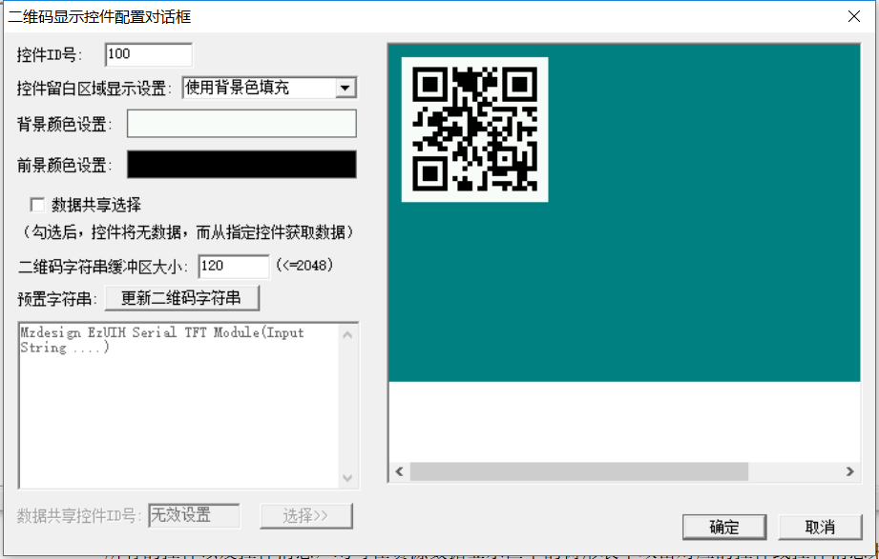

**Control White Space Display Settings:** When creating a control, the area configured by the user in the display region may not be square. After the generated QR code image is automatically enlarged, it may not fully fill the configured area. Therefore, this defines a white space relative to the configured area for the QR code image display. Users can choose appropriate white space processing methods based on their needs;

* Use background color fill: This option indicates that the control is filled with the background color configured by the control in the white area when displaying the QR code image. The example shown in the figure above is an example of using background color fill.
* No drawing (display background): This option indicates that the control will display a background image in the white space when displaying the QR code image.

**Background color setting:** set the background color when the QR code image is displayed. Click the color block on the right with the mouse to pop up a dialog box for setting;

**Foreground color setting:** set the foreground color when the QR code image is displayed;

Data Sharing: When the control is set to data sharing mode (i.e., the single option on the left is checked), the control will have no data buffer and cannot be updated or read through commands. The control needs to set the target control ID for data sharing. Once set, the control will obtain the QR code image from the designated target control and display it. The opposite state of data sharing mode is the proprietary data mode, where the control allows setting its own string data buffer size and can preset string content for the control.

**QR code string buffer size setting:** The QR code display control actually converts the strings set by the user to the control into QR code images for display. Therefore, the control needs a string buffer to store the content of the strings set by the user. This buffer can be configured according to needs. This setting is available when the control is in its own data mode.

**Pre-set String:** Users can pre-set the string content for the QR code display control after module initialization. If there is a pre-set string, the QR code display control will be displayed on the interface, converting the pre-set string into a QR code image for display. If the control currently has no string content, the QR code display control will not be shown on the interface. This setting requires the control to be in its own data mode to be configurable.

**Update the QR code String button:** Press this button to convert the string of the user preset QR code display control into a QR code image displayed in the preview area on the right side of the dialog box.

**Data sharing control ID:** When the control is in the shared data mode, the user can press the button on the right and select a QR code display control with the mode of own data mode in the dialog box that pops up. In this way, the current control will obtain the QR code image from the target control for display when the interface is updated.

## Modify the set controls and control messages

After the controls in the interface are set up and the control messages are configured, users can also select the controls or control messages to be modified from the tree table in the "Interface Controls" TAB.

All controls and control messages can be double-clicked in the tree table in the resource data display area to pop up the setting and configuration dialog box, in which you can make corresponding modification Settings and configurations.

For the modification of the control area, you need to select the control to be modified in the tree table first, and then click the area modification tool button in the toolbar, and the selected control will be presented with dotted lines and focus in the display area, as shown in the following figure:

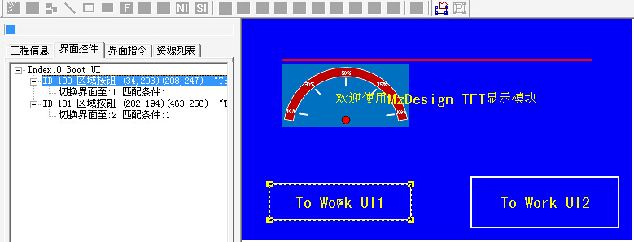

The user can use the left mouse button to drag the focus of the square to modify the area of the control, or use the direction keys in the keyboard to move the control up, down, left and right.

After the modification is completed, click the area modification tool button again to exit the area modification mode.

Modify the position of the control, or use the position modify tool in the toolbar to set the exact size of the position.

The area modification tool can also modify the area of multiple selected controls and display instructions.

## Operations in the tree table of the interface control

In the previous resource file, there are two area button controls in the "Boot UI" interface. Double-click the control with ID number 100 with the left mouse button, and modify the corresponding configuration in the configuration dialog box that pops up, as shown in the following figure:

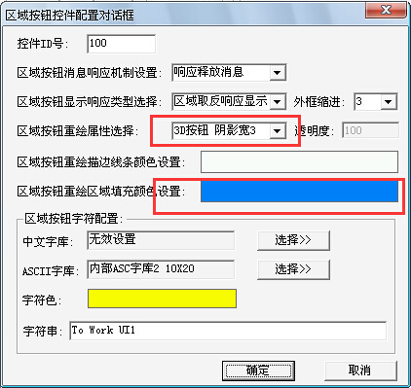

Click OK, and the effect of the back interface is shown in the following figure:

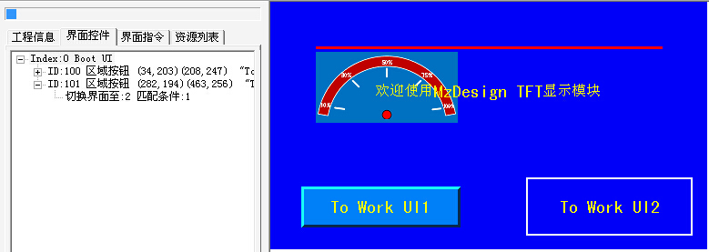

As can be seen in the figure, the display effect of the control with ID number 100 has changed greatly compared to the previous one, showing a three-dimensional effect; if you want to present the same effect for the control with ID number 101, you can use the copy and paste function of the control style in the right-click menu.

In the tree table of "interface control", right-click the menu at the control with ID number 100, select "Copy control style", and then right-click the menu at the control with ID number 101, select "Paste control style", as shown in the following figure:

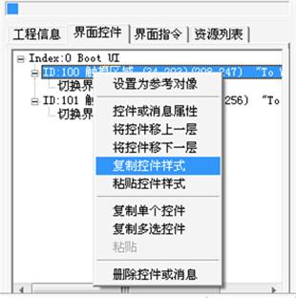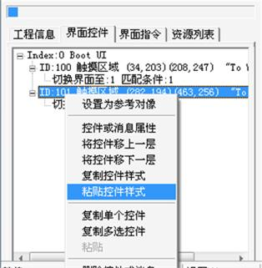

After the operation is completed, you can get the following effect:

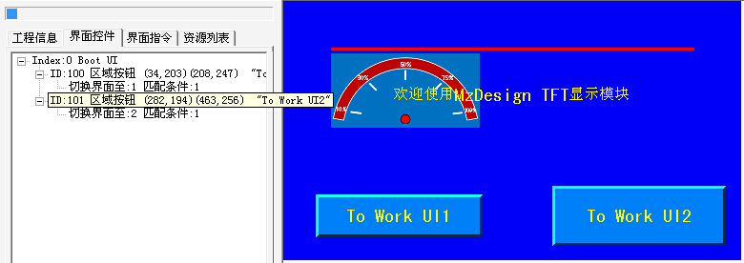

1. **Interface switching Settings**

The enhanced EzUIH series module provides interface switching effect effects, which can be configured in the EzUITool. In addition, the capacitive touch version of the EzUIH module also provides the function of touch slide screen to switch interfaces, which also needs to be set in the tool.

* 1. **Enable configuration interface switching effect and interface switching message sending**

When the user right-clicks on an interface item that has already been created and configured, a menu will pop up as shown in the following figure:

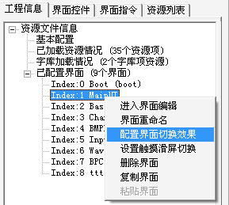

Click the menu item to open a dialog box, as shown in the following figure:

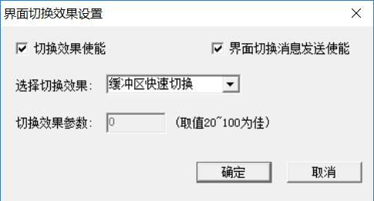

**"Interface Cut-and-Hold Message Send Enable":** This setting is enabled by default, indicating that after the interface switch, the GUI service engine message packet will be sent via the serial port. If this option is deselected, the serial port transmission of the message packet will not occur after the interface switch. (Note: The basic EzUI series modules do not support this function)

**"Switch effect usage":** This option can only be selected when the module is an enhanced EzUIH series. After this option is checked, the options below can be selected and set. If this option is not checked, it indicates that the current interface does not need the interface switching effect, and the interface switching drawing will be drawn according to the normal display mode.

**"Select Switch Effect":** There are several options in the drop-down list, as follows:

* Buffer quick switch: This configuration will allow the interface to be drawn in the buffer first when switching, and finally replace the image in the buffer quickly to the display screen.
* Transparency blur gradually in: This configuration will make the interface transition from a transparent state to the target interface, forming a blur gradual change effect.
* Vertical vertical window progressive display: This configuration will make the interface display a vertical bar window in the direction of vertical progressive display when switching, that is, multiple vertical bars are displayed synchronously with the width (pixels) set in the "switching effect parameters" to display the new target interface.
* Horizontal slat window progressive display: This configuration will make the interface display horizontal slat window in a gradual way when switching. That is, multiple horizontal bars with the width (pixels) set in the "switching effect parameters" will be displayed synchronously to show the new target interface.
* Random block entry: This configuration will allow the interface to be switched, and the target interface will be randomly piled up in the current display screen in blocks of the width set in the "switching effect parameters".
* Small window interface mode: This configuration will make the target interface defined as a local window when the interface is switched (the drawing instructions and related controls set in the target interface do not display and draw on the full screen). In this way, when the interface returns, it can quickly switch back to the previous interface.

Note: The small window interface mode only supports the first level of small window switching. For example, if the current interface is in the small window interface mode and then switches to another small window interface mode interface in the current interface, the small window interface mode will be invalid.

**"Switch effect parameter":** This setting is related to the previous switch effect setting and is only valid in certain Settings.

* 1. **Set touch swipe to switch**

This setting is only valid for the EzUIH module equipped with a capacitive touch screen. In the open dialog box, there are the following Settings:

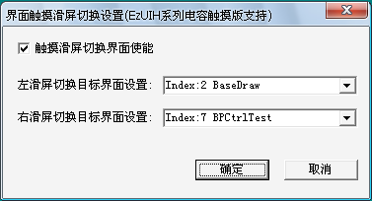

**"Enable touch swipe to switch interfaces":** If this option is selected, and if you have not previously set the left or right swipe target interface, the system will automatically set the options below. Then, users can select the target interface according to their needs. If this option is not selected, it indicates that the current interface does not allow swiping to switch interfaces.

**"Left swipe to switch target interface settings":** You can select the target interface in the drop-down box on the right; after selection, it means that when a swipe touch action from right to left occurs in the area without valid touchable controls on the touchscreen, the set target interface will be switched to the current display screen along with the swipe action.

**"Right swipe to switch target interface settings":** You can select the target interface in the drop-down box on the right; after selection, it means that when a swipe motion from left to right occurs in an area of the touch screen where no valid touchable control exists, the set target interface will be switched to the current display screen along with the swipe motion.

1. **Technical Support**

HotDisplay has extensive experience in LCD display drivers and has summarized a mature, universal LCD driver architecture through accumulation. This architecture can be easily ported to different LCD applications or different MCU application platforms. With the launch of new products, more complete drivers will be introduced. Users of these codes or application development software can use them with confidence in their products.

In terms of human-computer interface programming, HotDisplay will also provide users with more references, or customize special designs for users, so that users of HotDisplay can not only get high-quality and inexpensive products, but also obtain professional technical support.

The goal of HotDisplay is to be a professional provider of **products + technology in the industry.**

* 1. **contact way**

**BD14581_Hotdisplay Technology Co.Ltd**

**BD14581_Contact number: 0769-87298923 (Sales/Technology)**

**BD14581_Service email: lcd@hotlcd.com**